Touch of France
Dallas World Trade Center
2050 Stemmons Frwy. #10000
Unit 155 Dallas, Texas 75207
Tel: 214-698-1600
www.touch-of-france.com

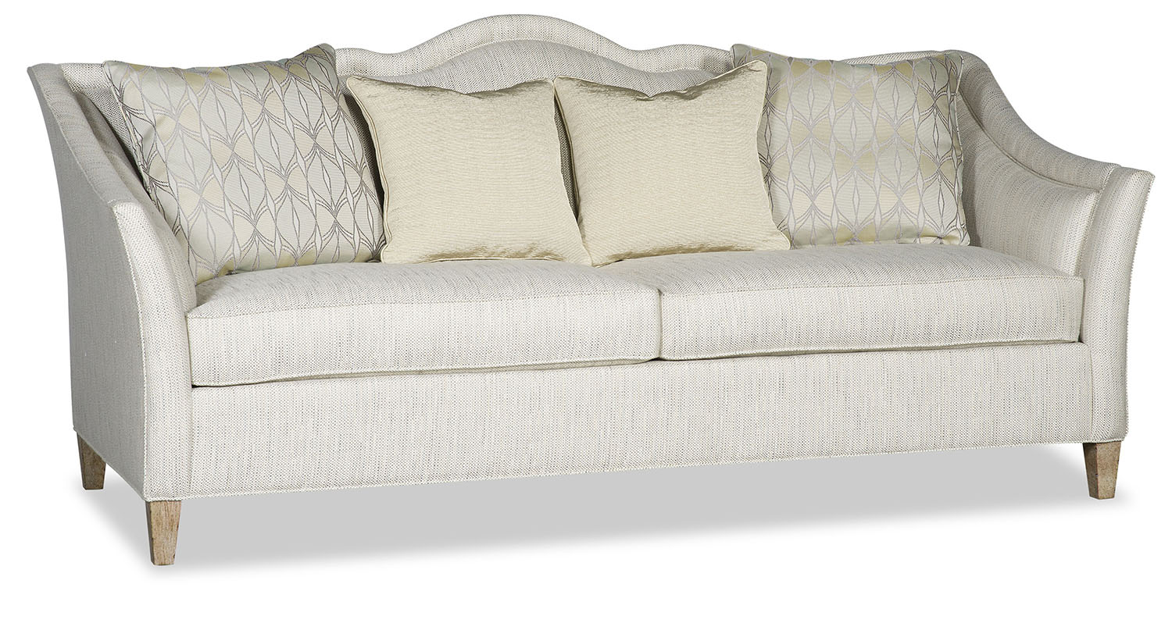

SIERRA SOFA

PR292-SIERRA
87”W x 42”D x 39”H

