Touch of France
Dallas World Trade Center
2050 Stemmons Frwy. #10000
Unit 155 Dallas, Texas 75207
Tel: 214-698-1600
www.touch-of-france.com
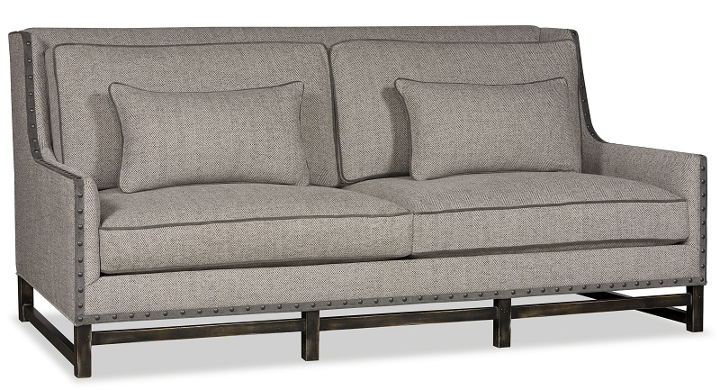

PADDY SOFA

215 Paddy
(Inches) H41 W86 D44 IW78 AH24 SH20 SD18

