Touch of France
Dallas World Trade Center
2050 Stemmons Frwy. #10000
Unit 155 Dallas, Texas 75207
Tel: 214-698-1600
www.touch-of-france.com

BEN 3 PIECE SECTIONAL
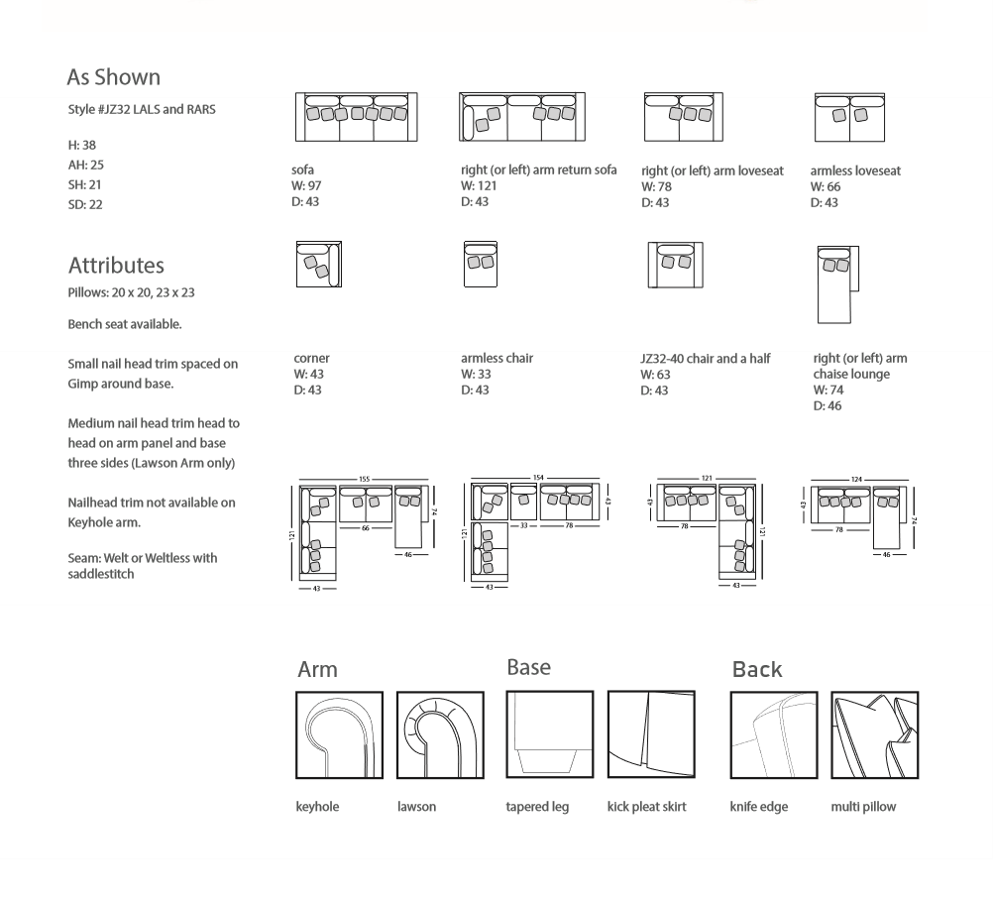

PRJZ32-ALS/LARS/RAC
121”W X 155”W X 37” H
74” DEEP AT CHAISE
43” DEEP AT SOFA

