

Lyre Round Dining Table
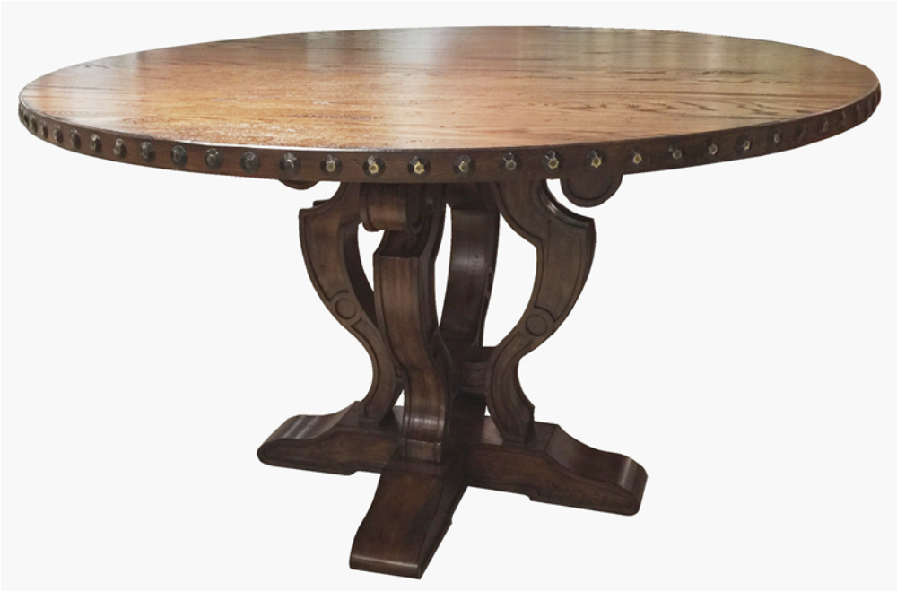

Artisans work, Hand Carved

Available: 48”, 54”, 60”, 72” Diam
X30”H
Customizing Available
Several Finish Choices

