Touch of France
Dallas World Trade Center
2050 Stemmons Frwy Suite 10000
Unit 155 Dallas, Texas 75207-3211
Tel: 214-698-1600
Fax: 214-698-1601
www.touch-of-france.com

d’ AUTEUIL
COFFEE TABLE
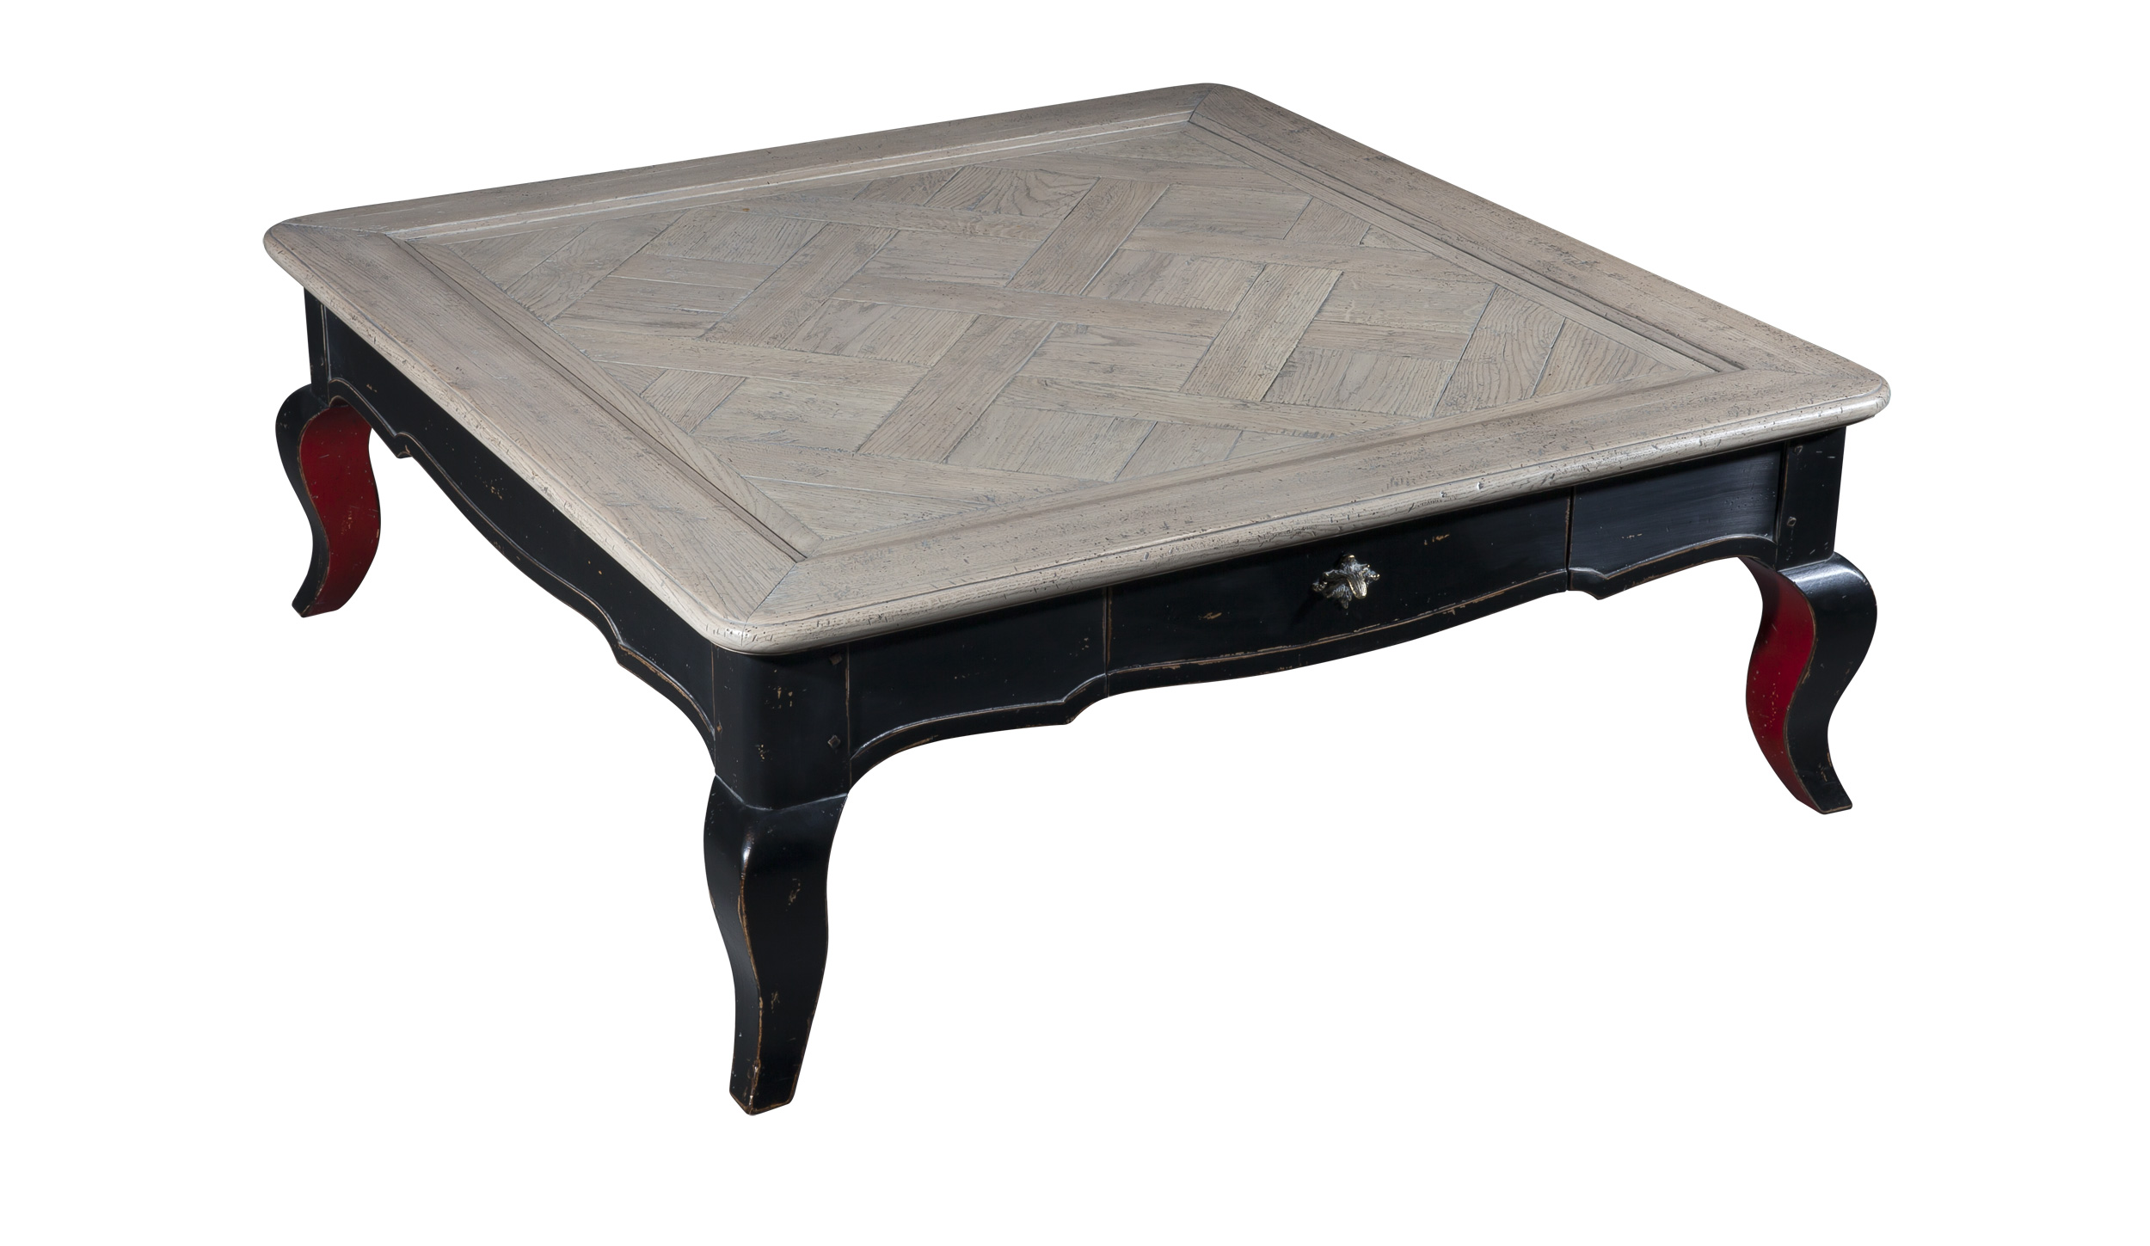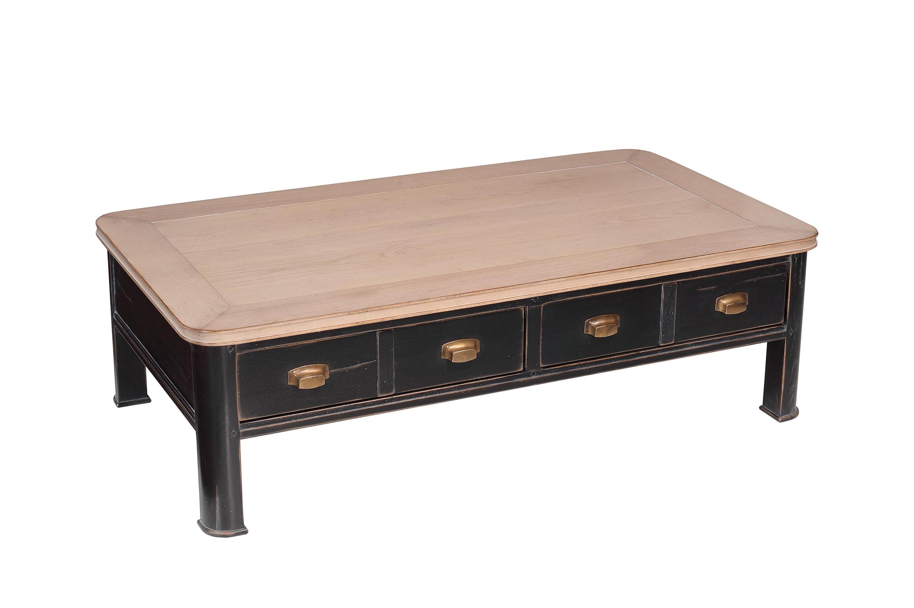
DIMENSIONS: 1.15m X .1.15m X .42m h
45.3” X 45.3” X 16.5” h
Other finishes available

