Touch of France
Dallas World Trade Center
2050 Stemmons Frwy Suite 10000
Unit 155 Dallas, Texas 75207-3211
Tel: 214-698-1600
Fax: 214-698-1601
www.touch-of-france.com

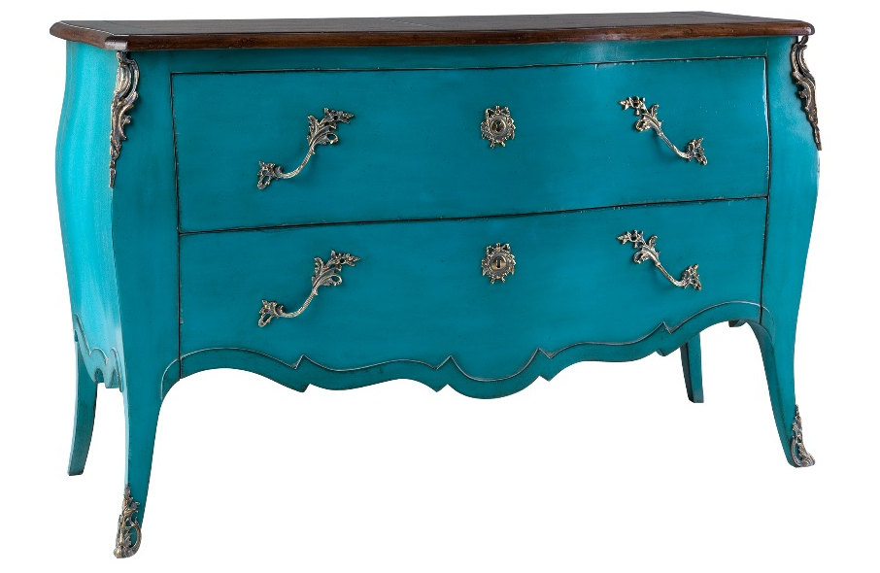
d’ AUTEUIL CHEST OF DRAWERS

DIMENSIONS: 1.44m X .54m X .90m h
56.7” X 21.3” X 35.4” h
Other finishes available

