Touch of France
Dallas World Trade Center
2050 Stemmons Frwy. #10000
Unit 155 Dallas, Texas 75207
Tel: 214-698-1600
www.touch-of-france.com

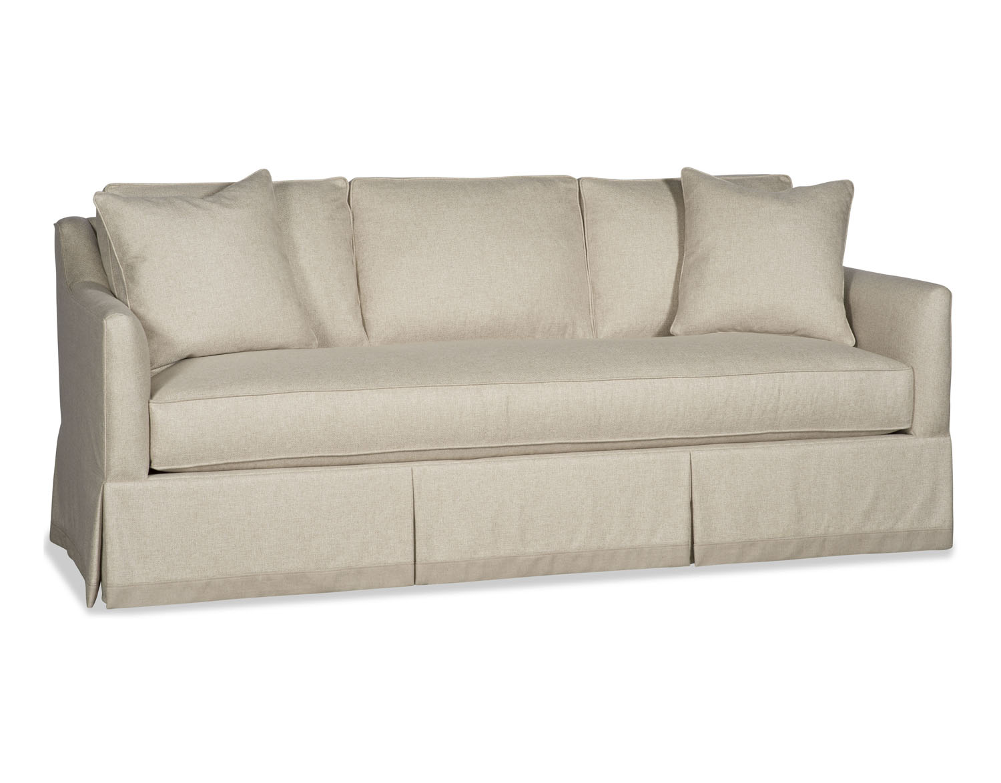

VINCENT SOFA

PR122-75 SOFA

41H x 75W x 37D

OTHER OPTIONS AVAILABLE

Also Available in 99” Width

