Touch of France
Dallas World Trade Center
2050 Stemmons Frwy Suite 10000
Unit 155 Dallas, Texas 75207-3211
Tel: 214-698-1600
Fax: 214-698-1601
www.touch-of-france.com

VICTOIRE ROUND
DINING TABLE

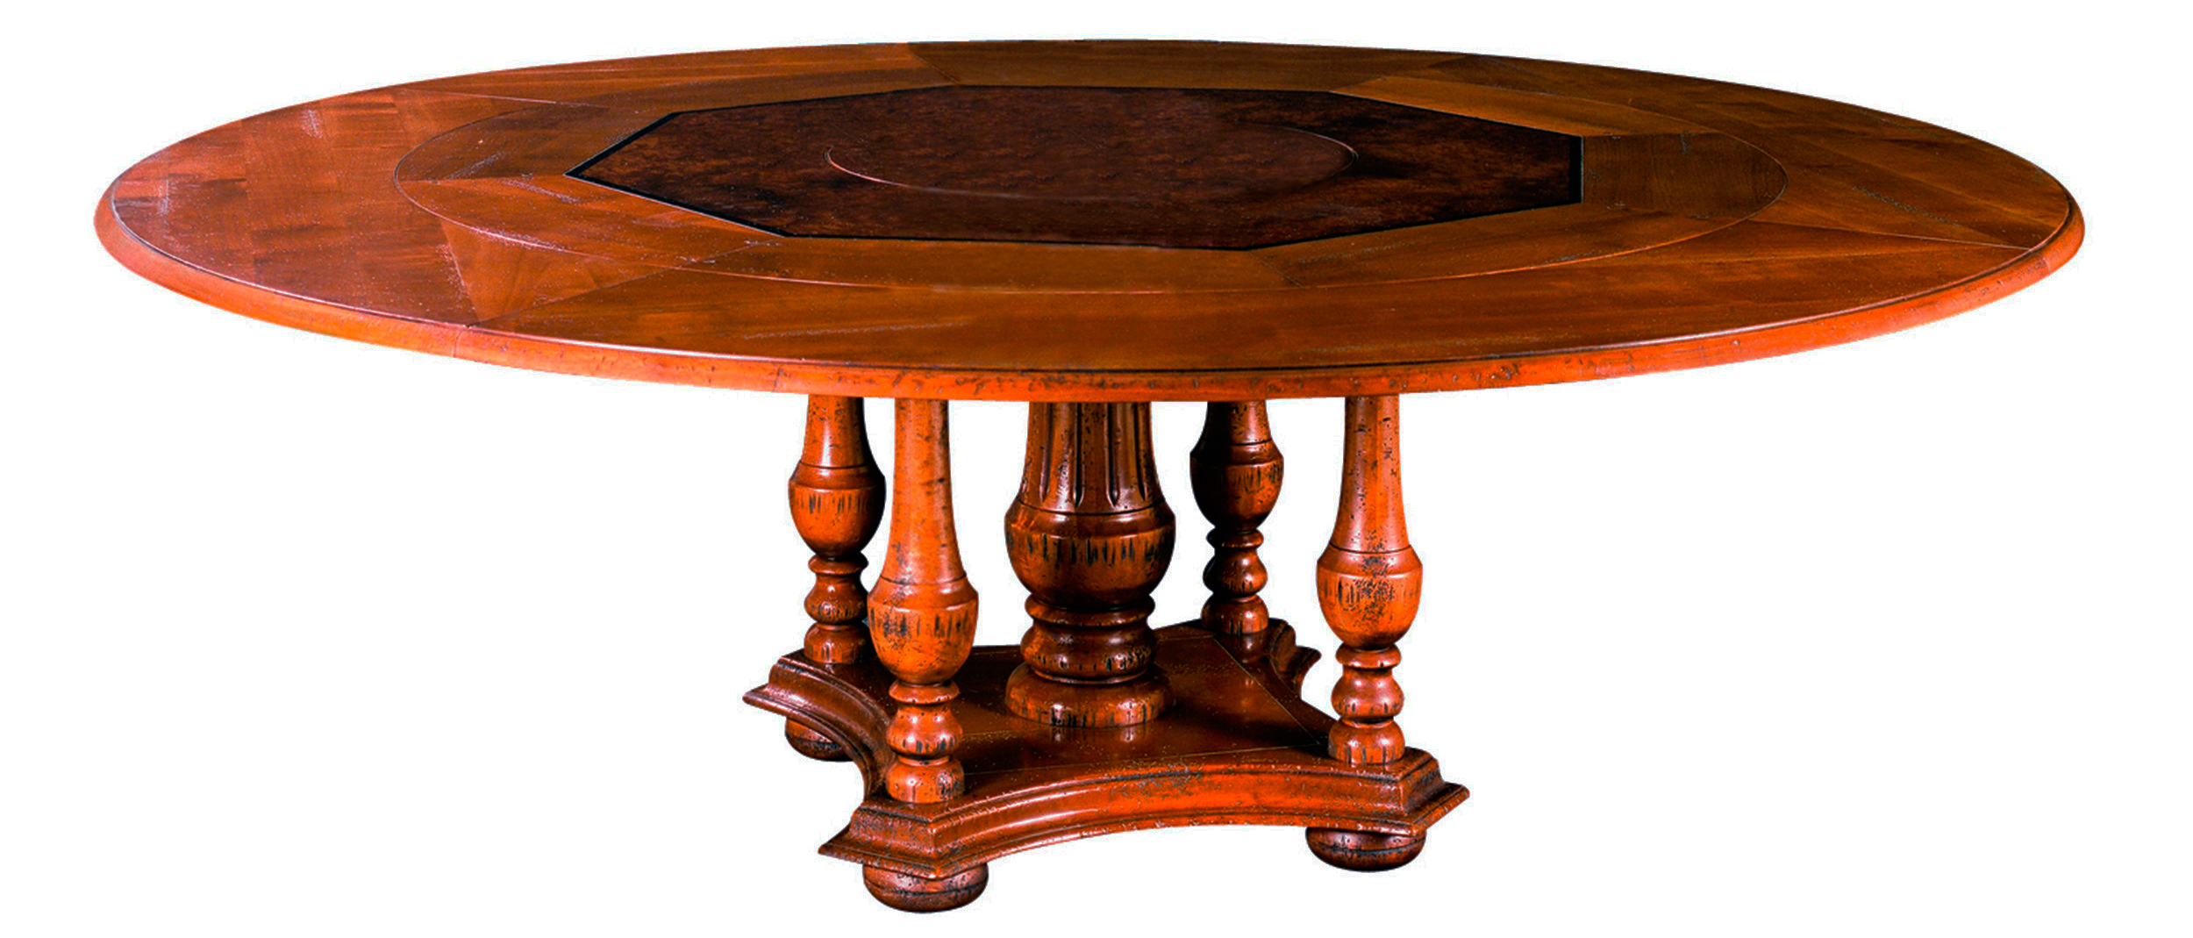

DIMENSIONS: 1.60m Diameter X .77m H
63” Diameter X 30”H
Diameter can go up to 2.10m / 86” when extensions are on
Center table is Burlwood and Lazy Susan is optional
Other finishes available

