Touch of France
Dallas World Trade Center
2050 Stemmons Frwy Suite 10000
Unit 155 Dallas, Texas 75207-3211
Tel: 214-698-1600
Fax: 214-698-1601
www.touch-of-france.com

SOLONGE CONSOLE
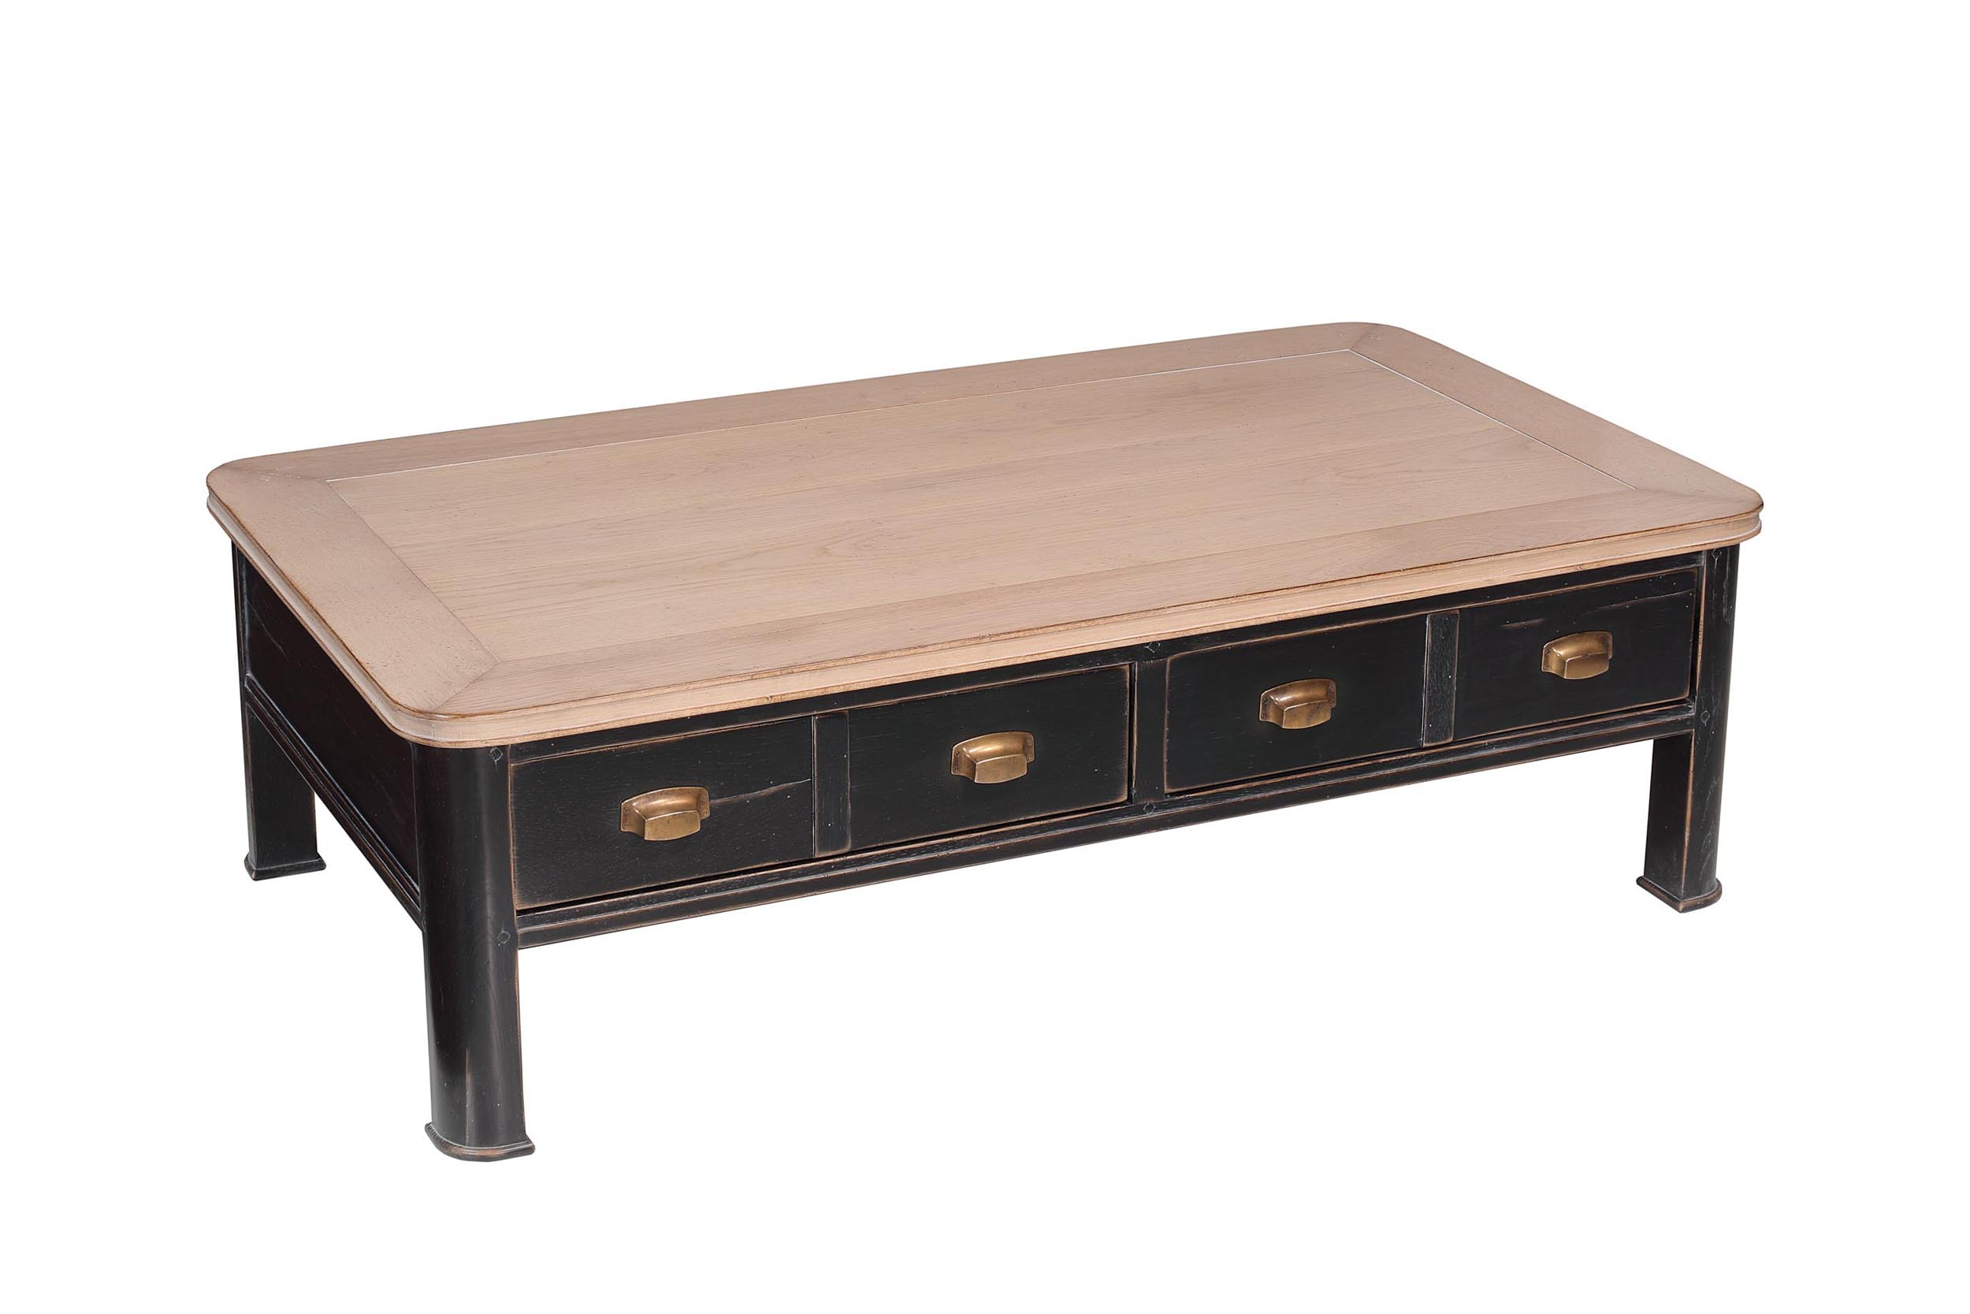

DIMENSIONS: 2.00m X .40m X .78m h
78.7” X 15.7” X 30.7” h
2 Drawers
Other finishes available

