Touch of France
Dallas World Trade Center
2050 Stemmons Frwy Suite 10000
Unit 155 Dallas, Texas 75207-3211
Tel: 214-698-1600
Fax: 214-698-1601
www.touch-of-france.com

RAMBOUILLET DINING TABLE
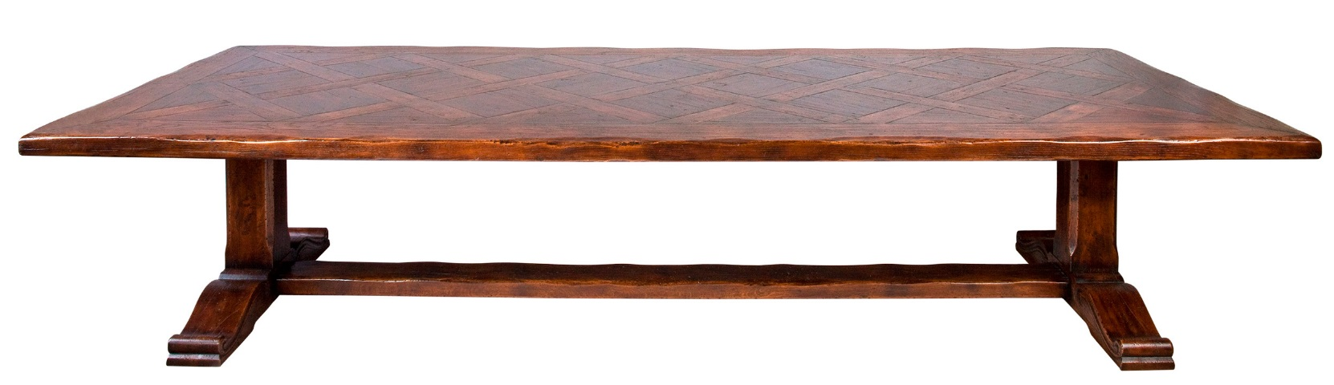

DIMENSIONS: AVAIL- 210, 240, 270, 300, 330, 360cm X 1.15m D X .77m H
7’, 8’, 9’, 10’, 11’, 12’ X 45.2” D X 30”H
Oak and Walnut Parquetry
Extensions can be added at each end of table
Available in any custom dimensions
Other finishes available

