

Artisans work, Hand Carved.
Available in: 36”x 42”H
also available in Counter Height

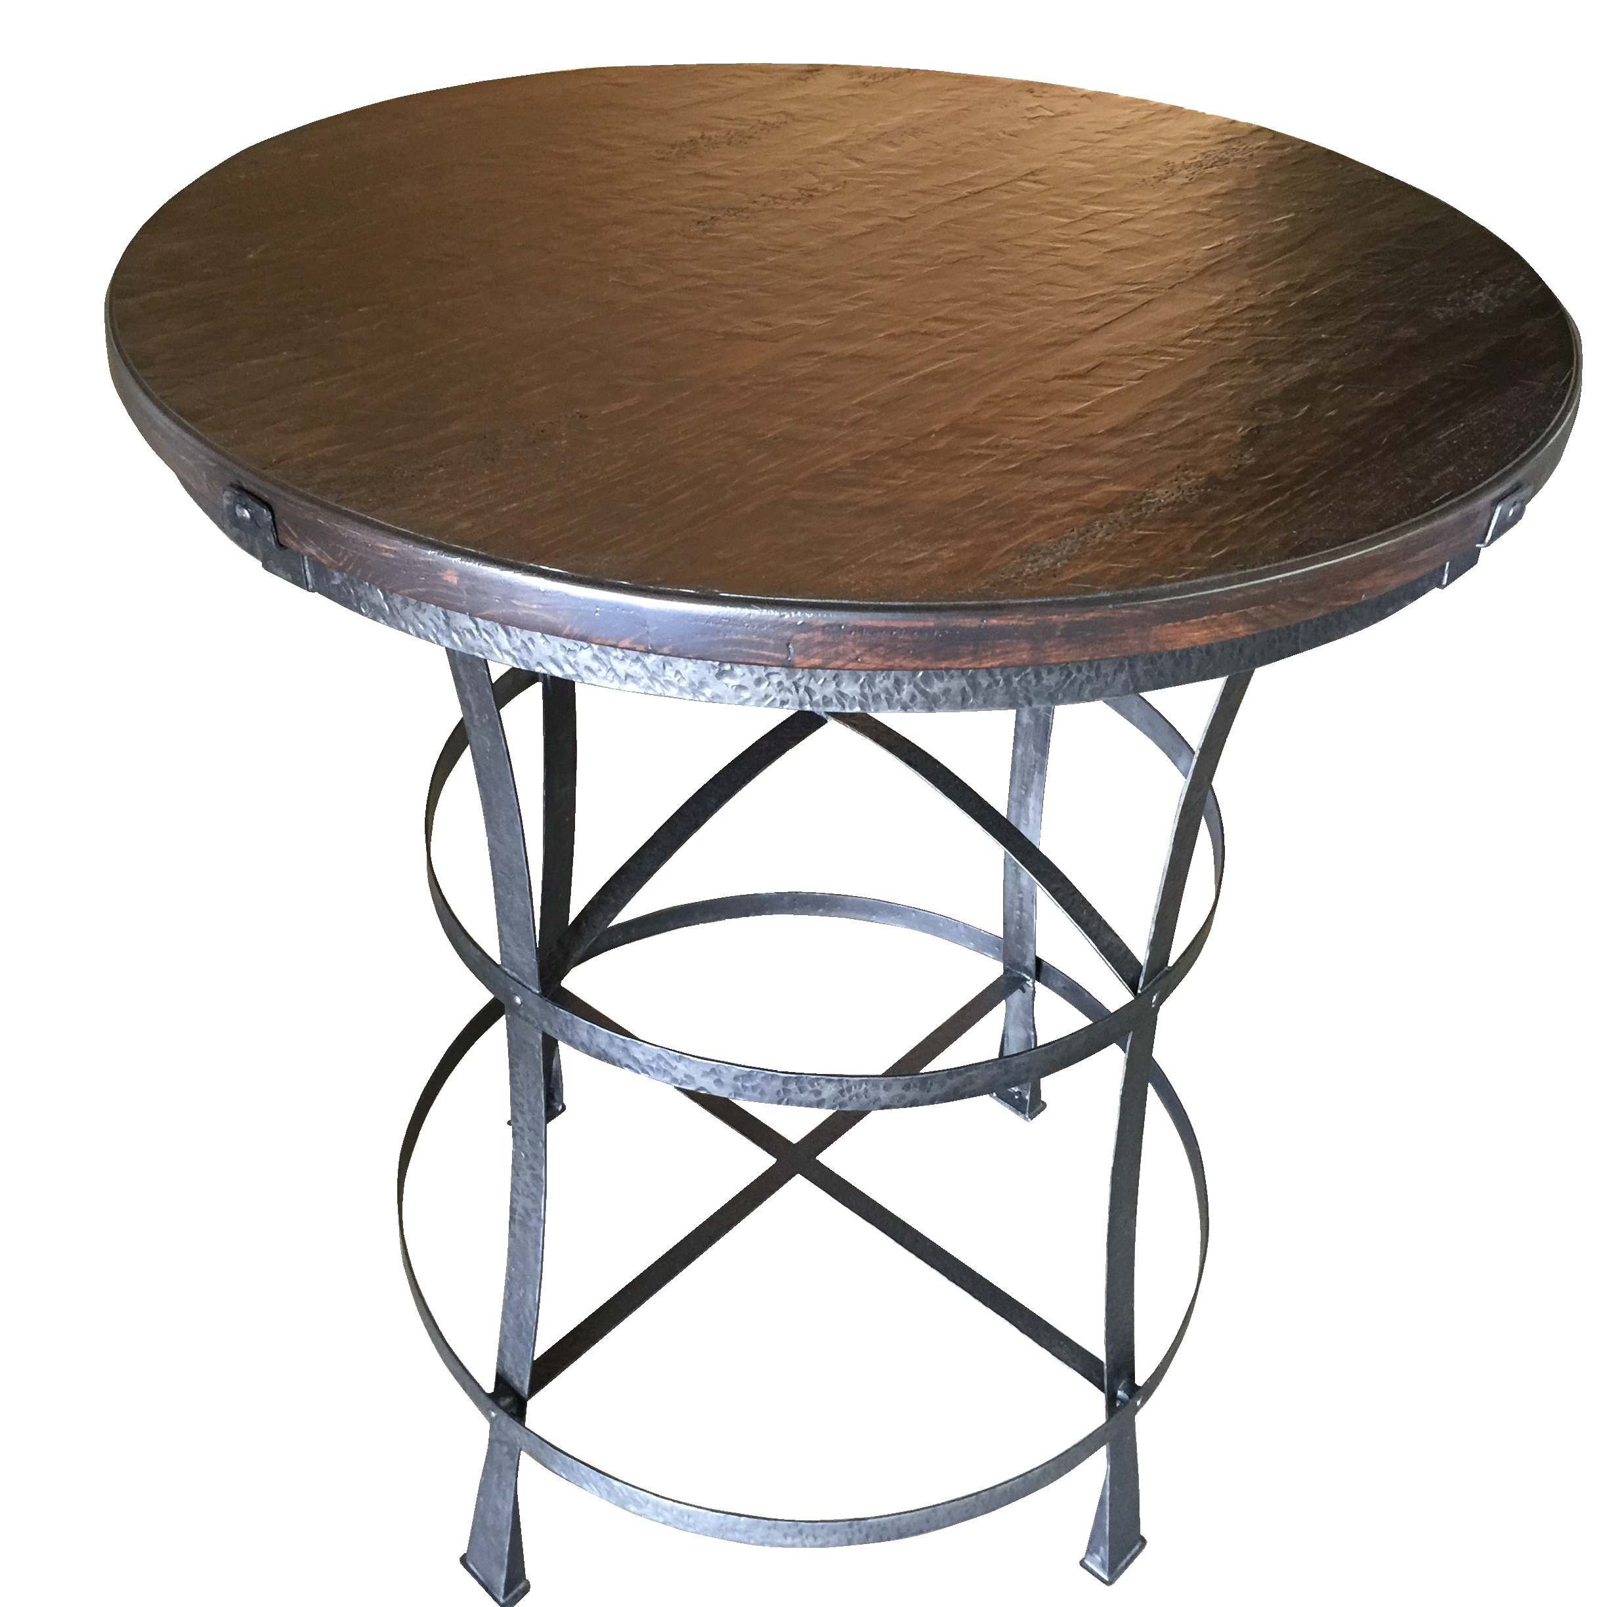

Montana Bar Table

