Touch of France
Dallas World Trade Center
2050 Stemmons Frwy Suite 10000
Unit 155 Dallas, Texas 75207-3211
Tel: 214-698-1600
Fax: 214-698-1601
www.touch-of-france.com

MONASTERE
DINING TABLE

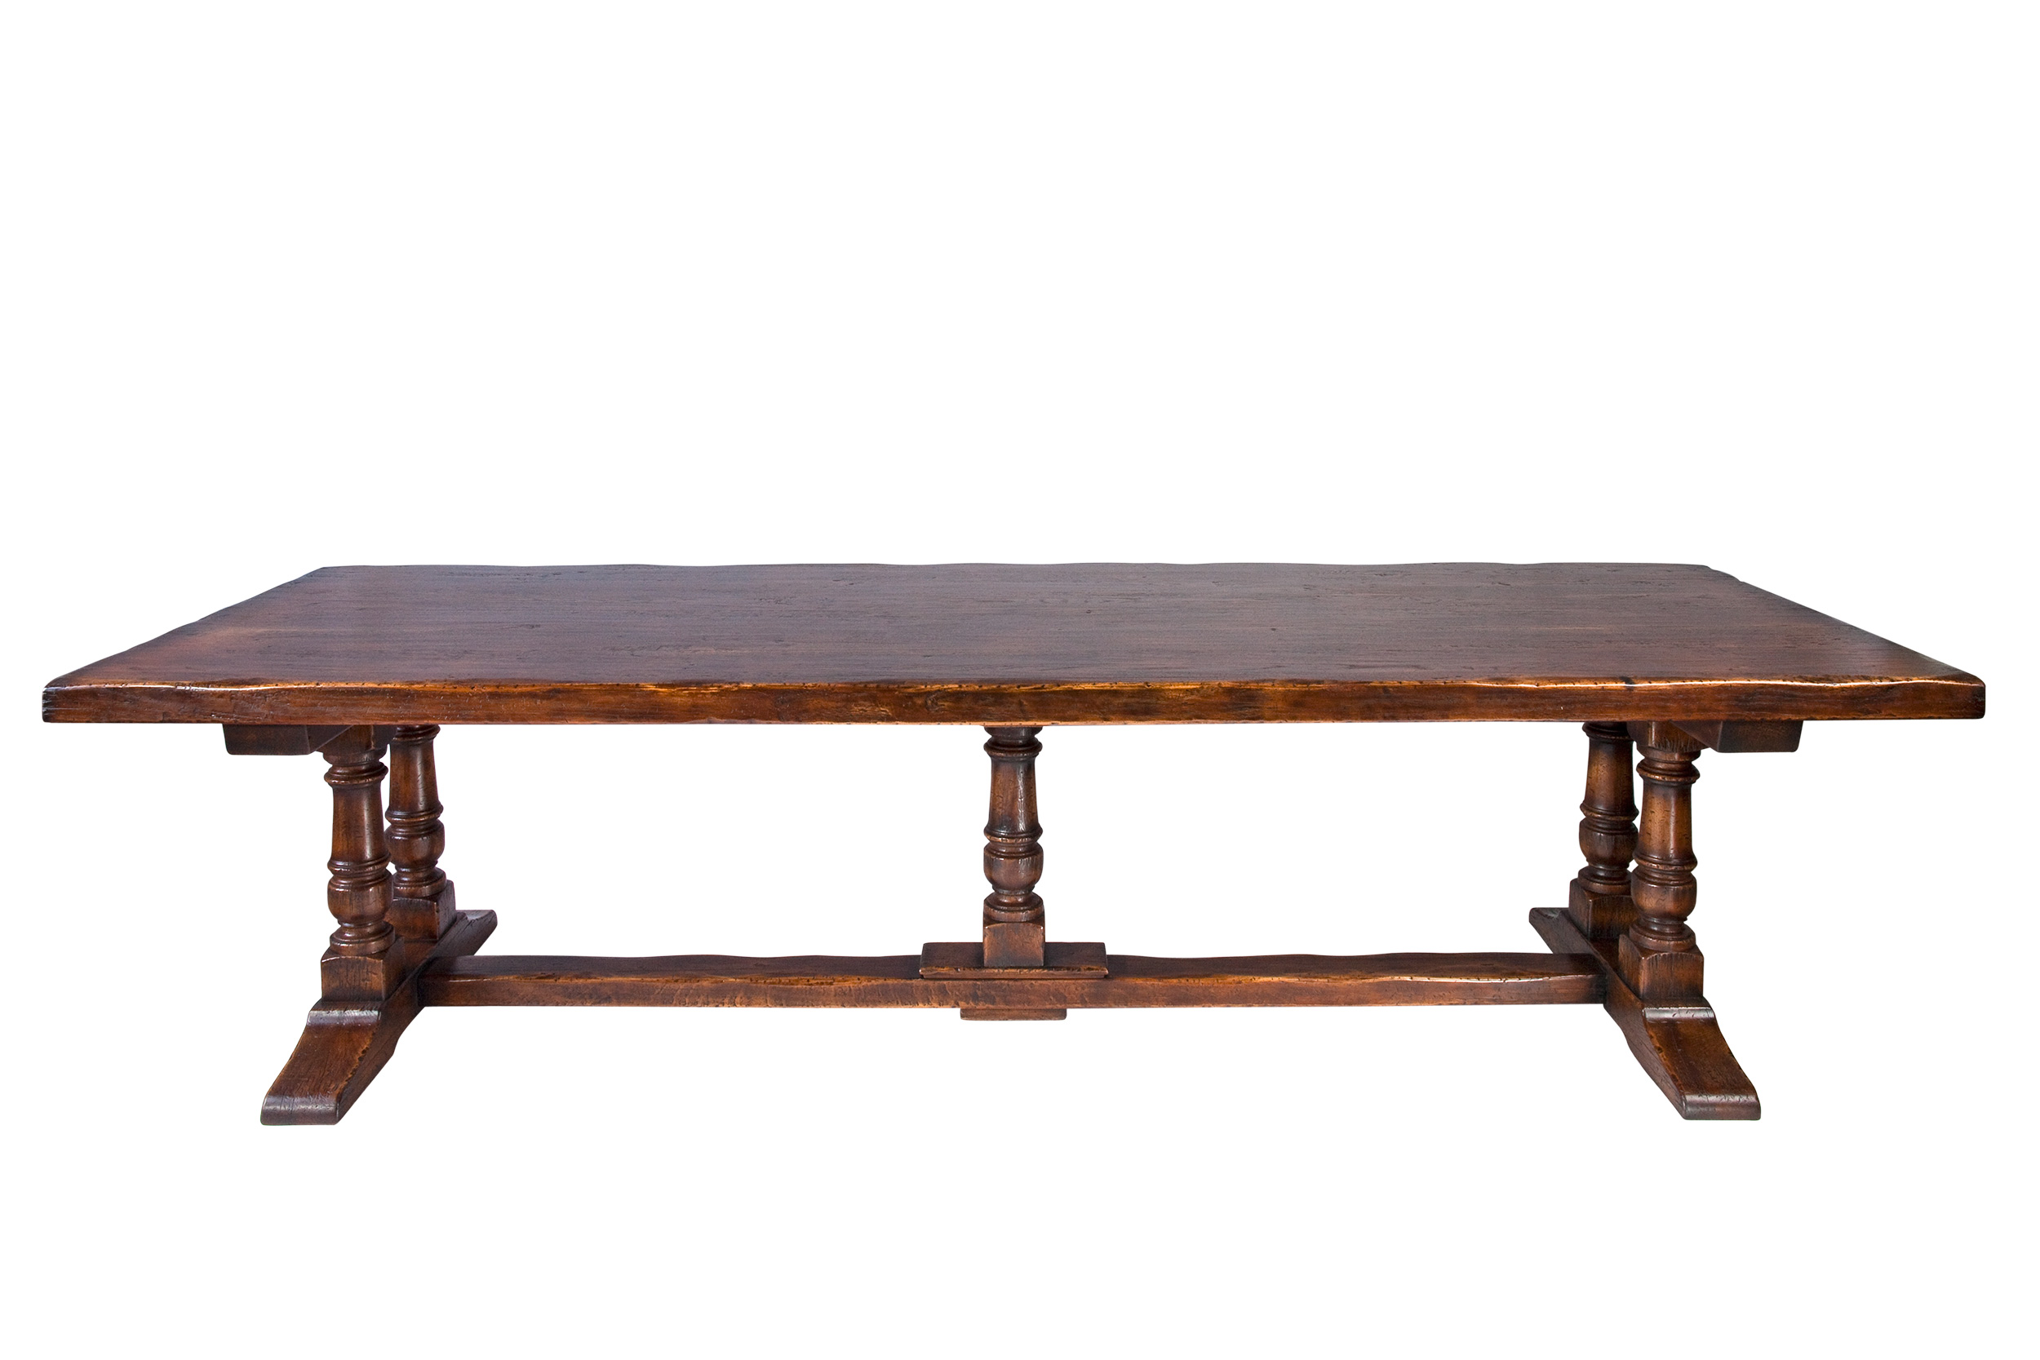

DIMENSIONS: AVAIL- 210, 240, 270, 300, 330, 360cm W X 1.10m D X .77m H
7’, 8’, 9’ 10’ 11’ 12’ W X 43.3” D x 30”H
Butterfly extensions can be added at each end
Avail in any custom dimensions
Wood- Oak
More finishes available

