Touch of France
Dallas World Trade Center
2050 Stemmons Frwy Suite 10000
Unit 155 Dallas, Texas 75207-3211
Tel: 214-698-1600
Fax: 214-698-1601
www.touch-of-france.com

MALARME CHEST OF DRAWERS
WITH TV LIFT

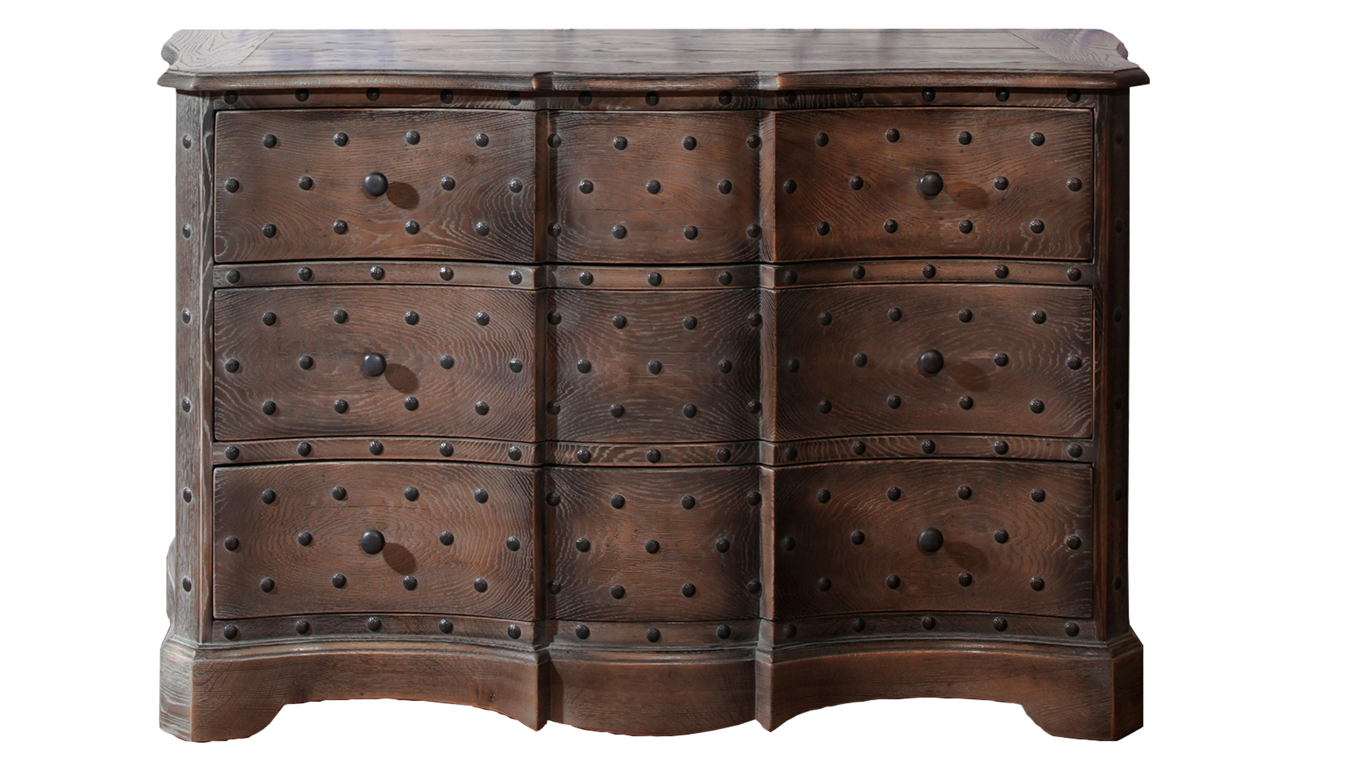

DIMENSIONS: 1.53m X .65m X 1.53m H
60.2” X 25.6” X 37.4”H
3 Drawers- top drawer flips open
1 electrical TV lift
Other finishes available

