Touch of France
Dallas World Trade Center
2050 Stemmons Frwy Suite 10000
Unit 155 Dallas, Texas 75207-3211
Tel: 214-698-1600
Fax: 214-698-1601
www.touch-of-france.com

HUNT TABLE WITH
TWISTED LEGS
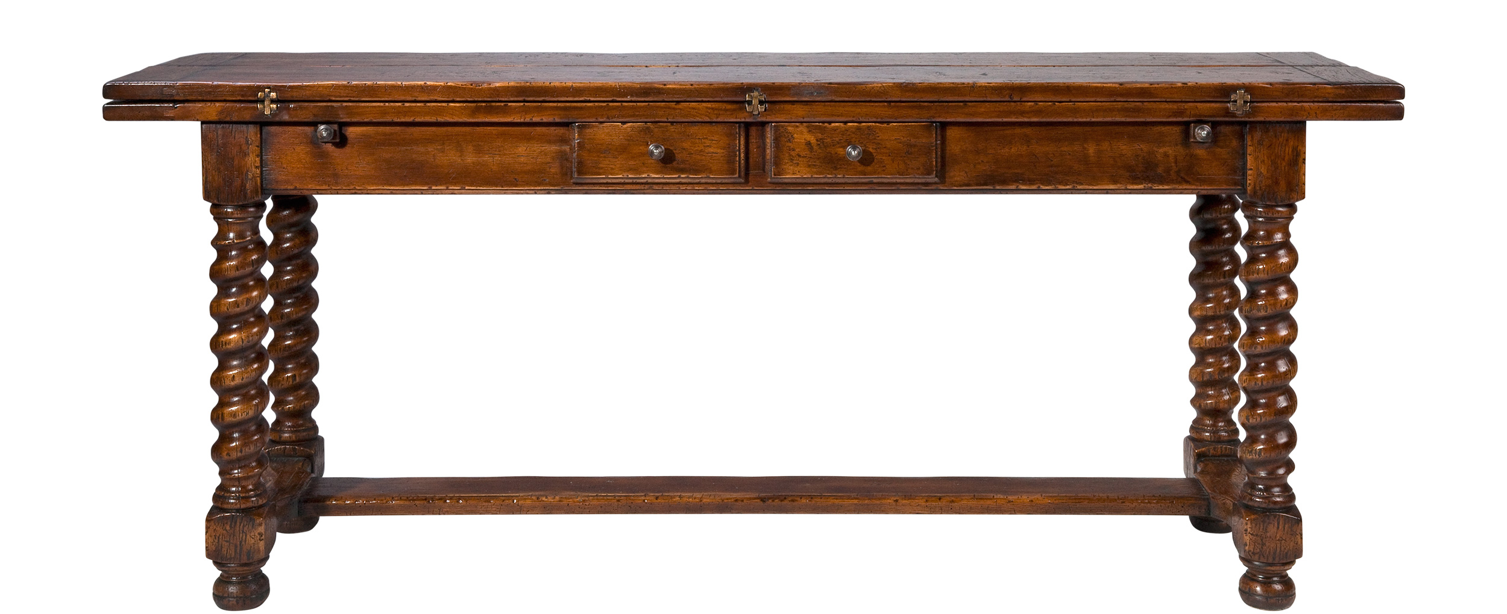

DIMENSIONS: 1.83m X .46m closed & .92m open X .77m h
72” X 18.1 closed & 36.02” open X 29.9” h
1 Drawer simulates 2
Other finishes available

