

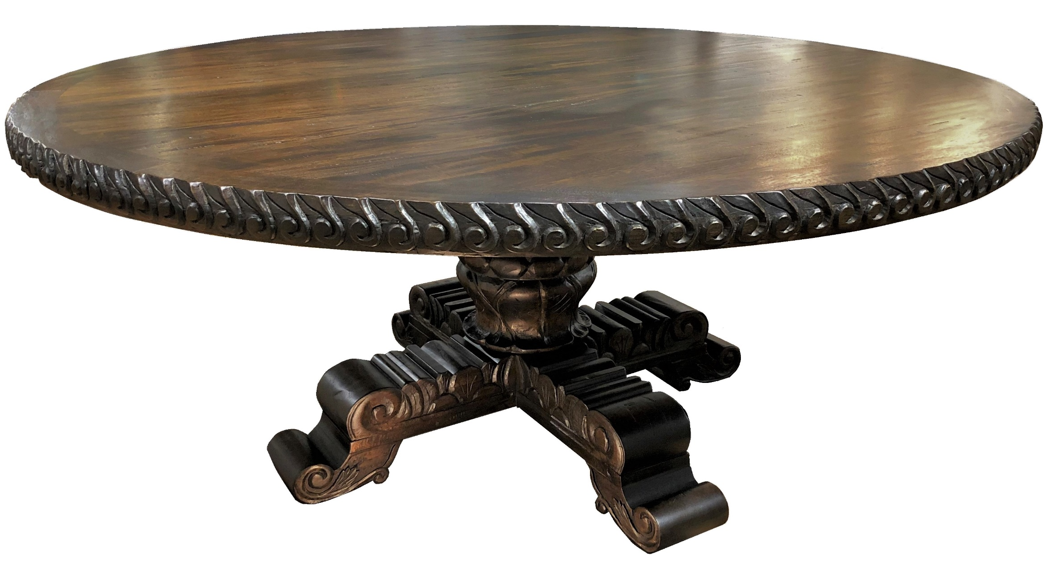

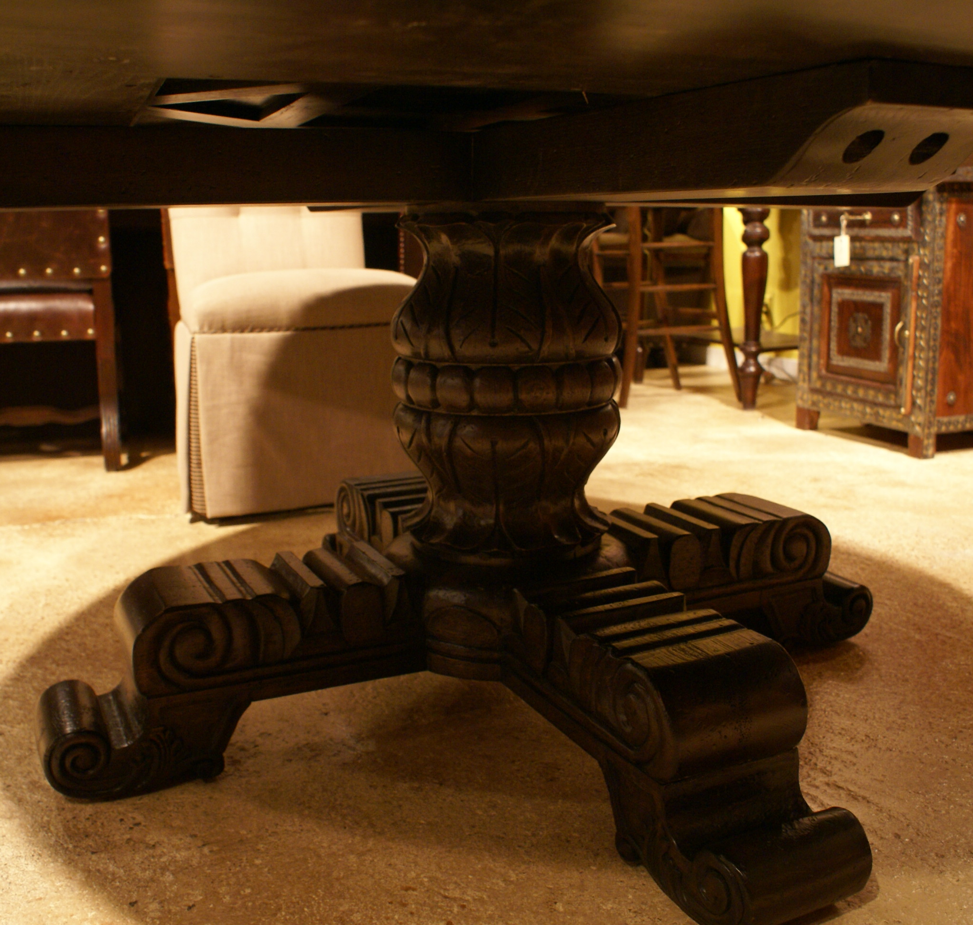
Artisans work, Solid Oak, Hand Carved

Available in: 54”, 60”, 72”, 84”
Custom sizing also available

Fontainebleau Round Dining Table

