Touch of France
Dallas World Trade Center
2050 Stemmons Frwy Suite 10000
Unit 155 Dallas, Texas 75207-3211
Tel: 214-698-1600
Fax: 214-698-1601
www.touch-of-france.com

FAUBORG GRANDE CONSOLE
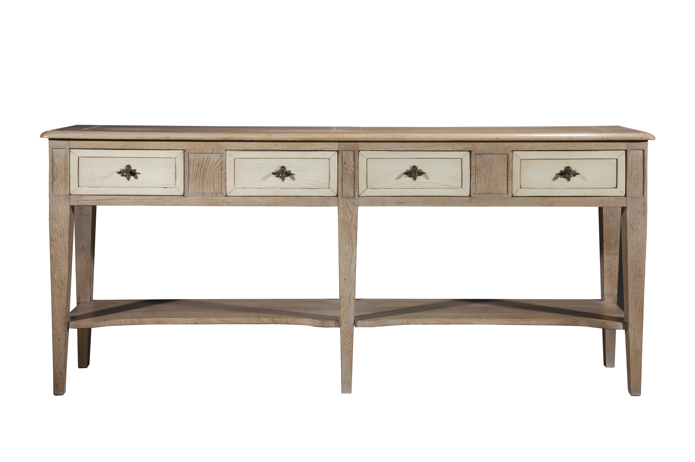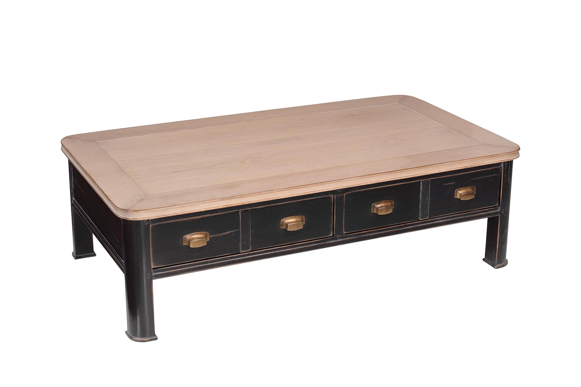
DIMENSIONS: 1.80m X .38m X .80m h
70.9” X 15” X 31.5” h
4 Drawers
Other finishes available

