Touch of France
Dallas World Trade Center
2050 Stemmons Frwy Suite 10000
Unit 155 Dallas, Texas 75207-3211
Tel: 214-698-1600
Fax: 214-698-1601
www.touch-of-france.com

FAUBOURG
COFFEE TABLE
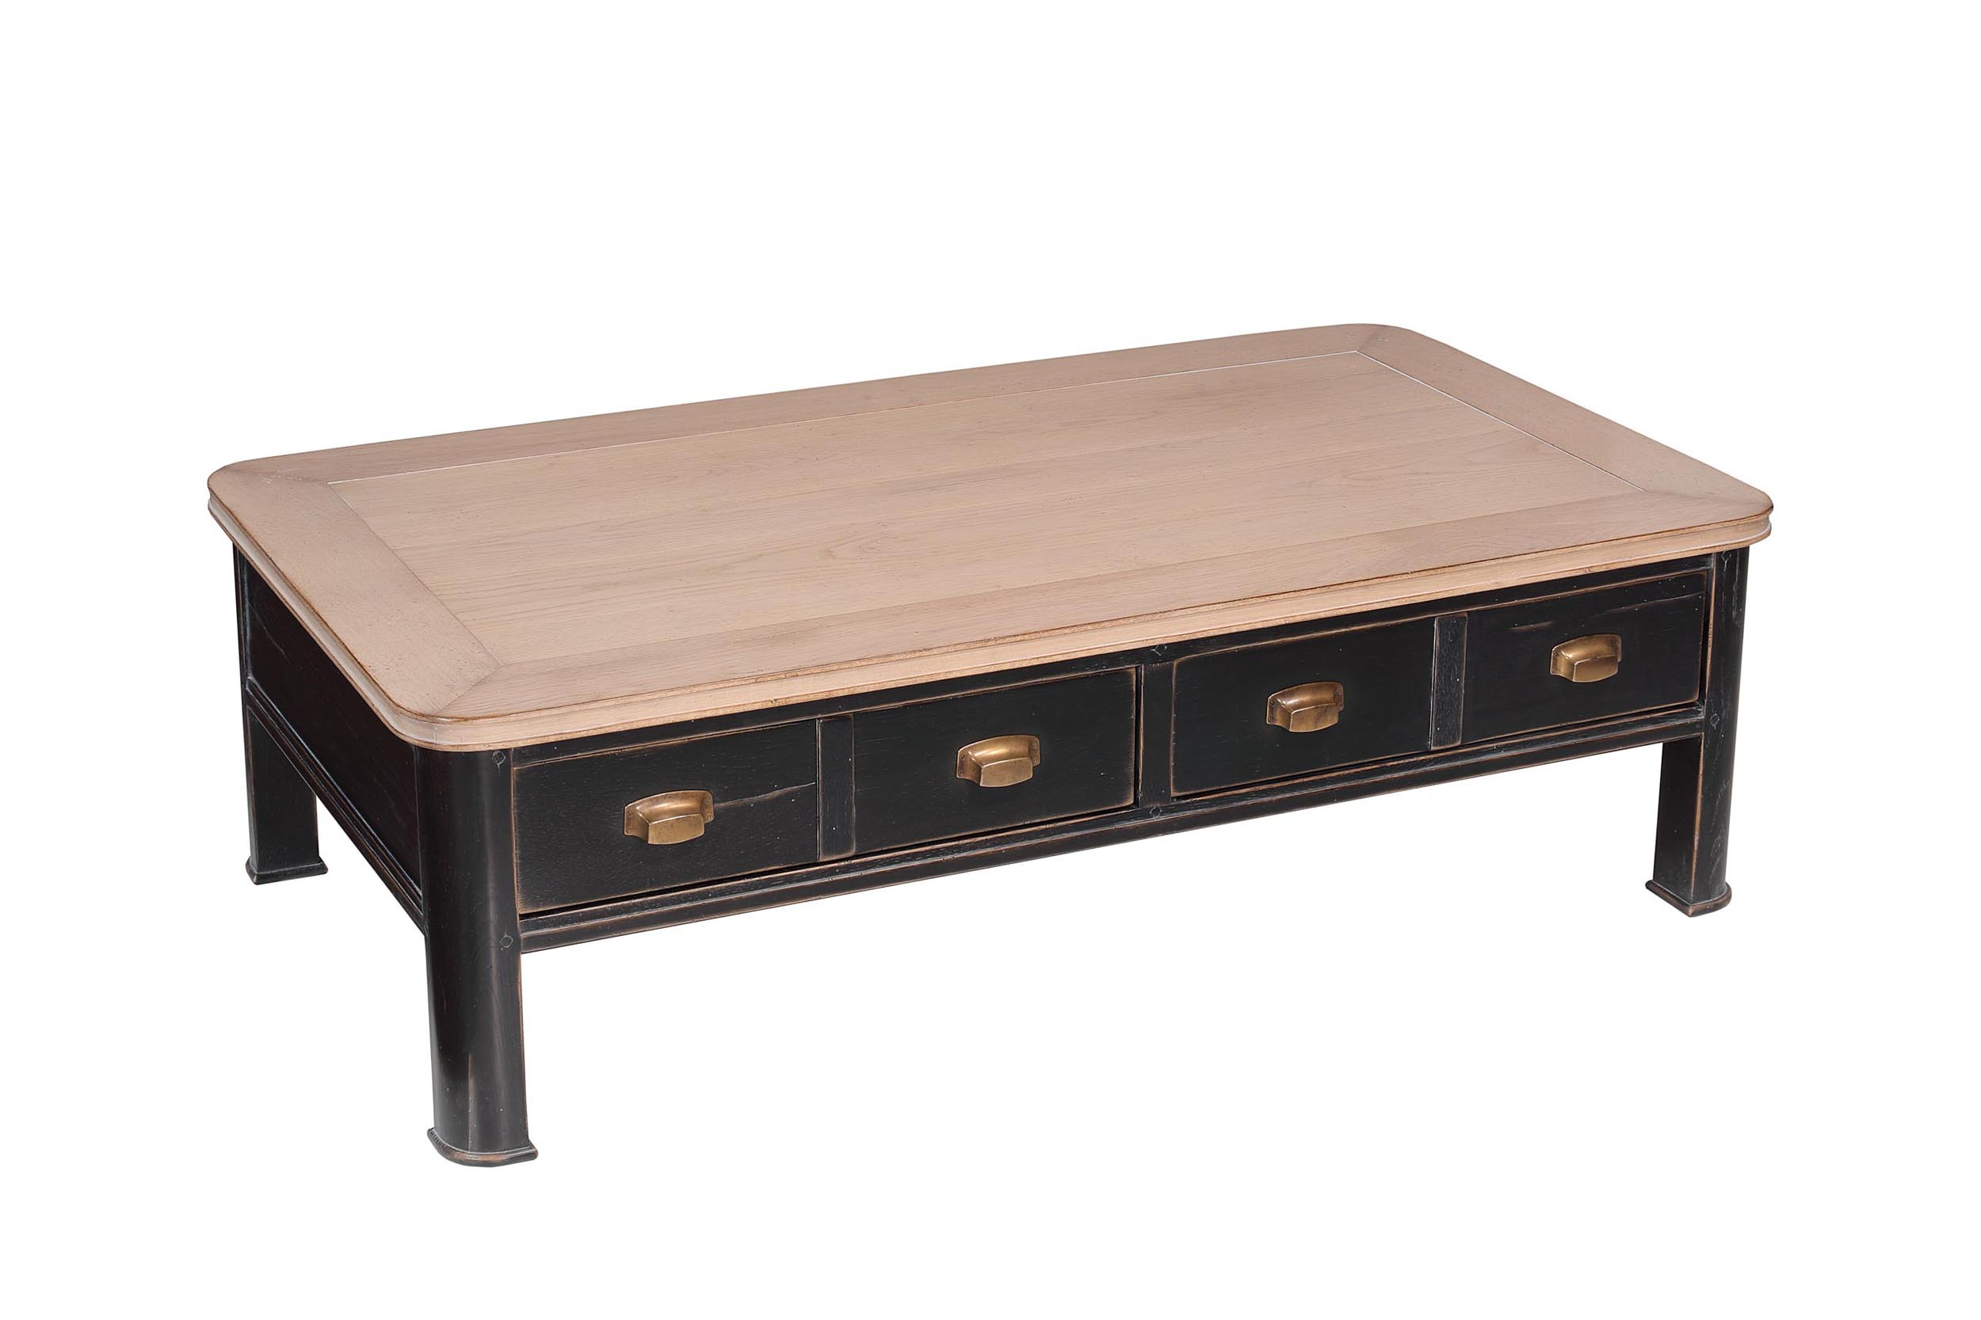
DIMENSIONS: 1.30m X .80m X .40m h
51.2” X 31.5” X 15.7” h
Other finishes available

