Touch of France
Dallas World Trade Center
2050 Stemmons Frwy. #10000
Unit 155 Dallas, Texas 75207
Tel: 214-698-1600
www.touch-of-france.com

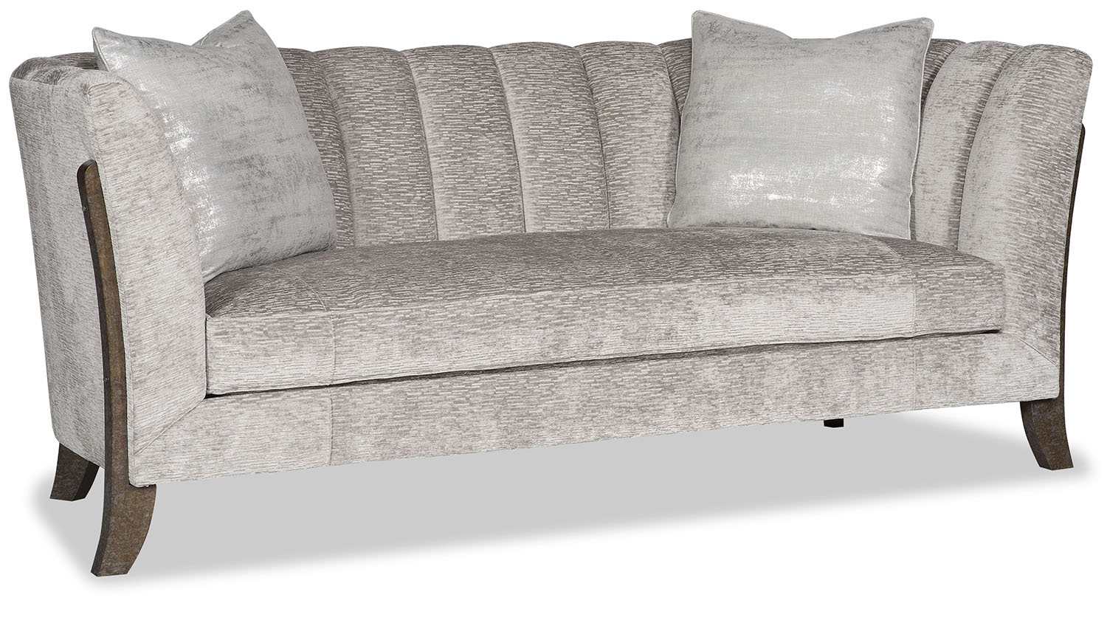

EDIE SOFA

PR-489-EDIE

35H x 85w x 35d

