Touch of France
Dallas World Trade Center
2050 Stemmons Frwy. #10000
Unit 155 Dallas, Texas 75207
Tel: 214-698-1600
www.touch-of-france.com

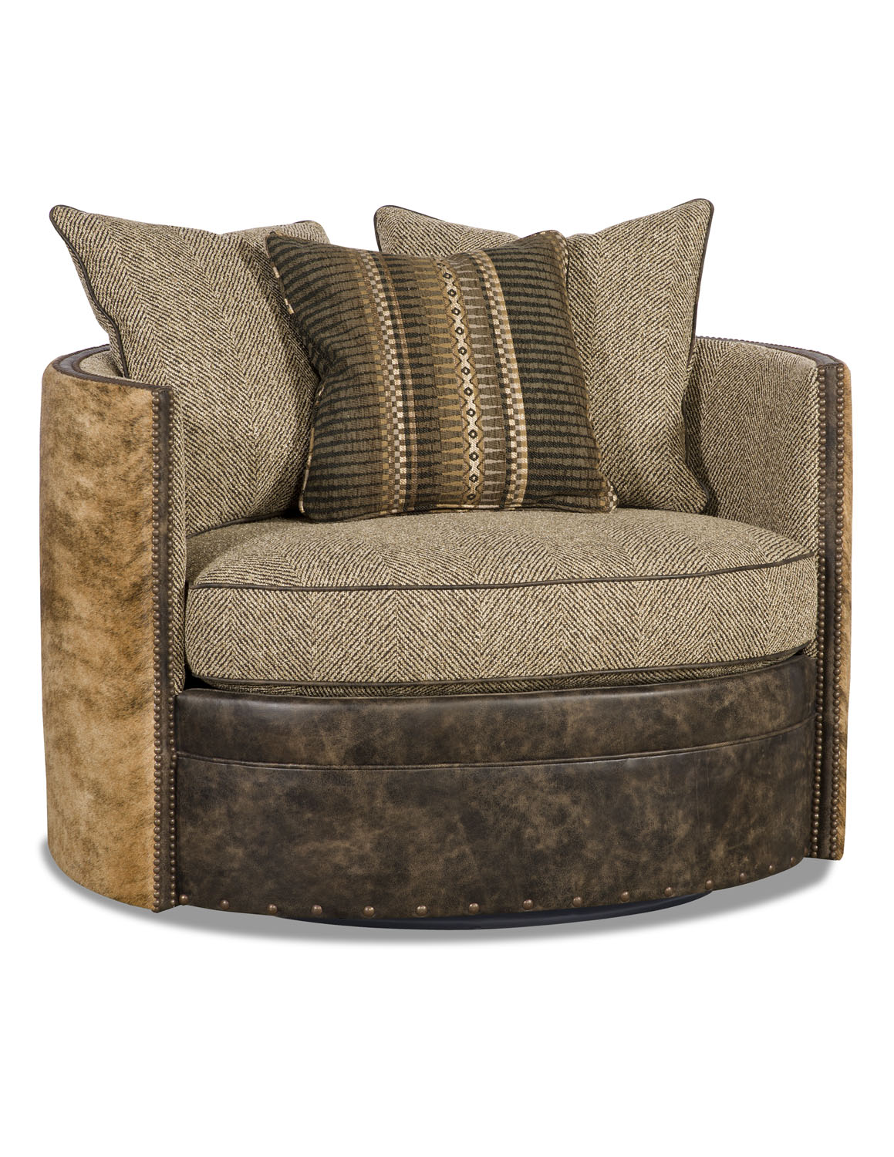

DYSON SWIVEL

PR665-10 SWIVEL

38H x 47W x 40D

