Touch of France
Dallas World Trade Center
2050 Stemmons Frwy. #10000
Unit 155 Dallas, Texas 75207
Tel: 214-698-1600
www.touch-of-france.com

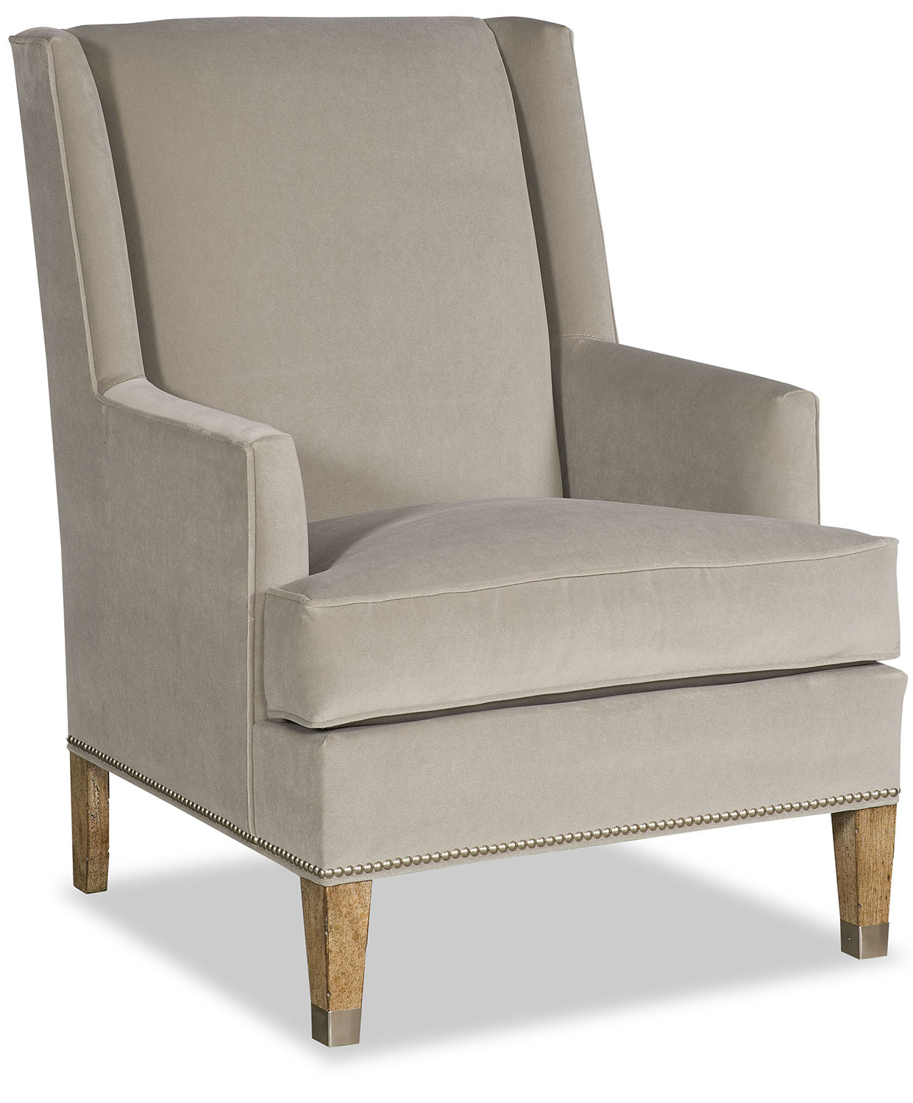

DORIS CHAIR

PR-2274-DORIS

41H x 28W x 33D

*Also available skirted with a swivel*

