

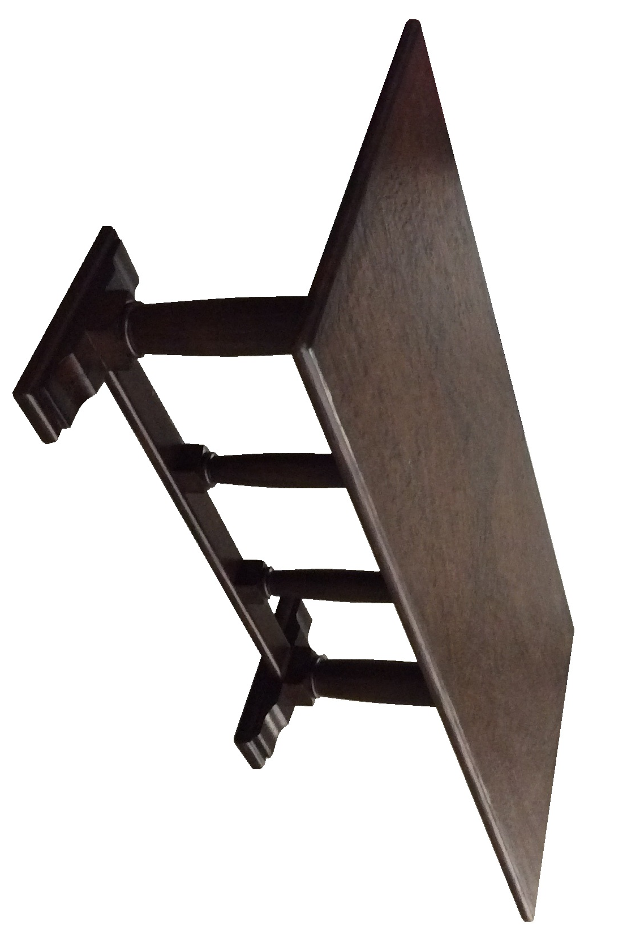

Available in: 72”x 36”
84”x 36”
96”x 36”
Custom sizing and finish choices

Artisans work, Hand Carved

Diamond Dining Table

