Touch of France
Dallas World Trade Center
2050 Stemmons Frwy Suite 10000
Unit 155 Dallas, Texas 75207-3211
Tel: 214-698-1600
Fax: 214-698-1601
www.touch-of-france.com

CHARTREUSE
DINING TABLE

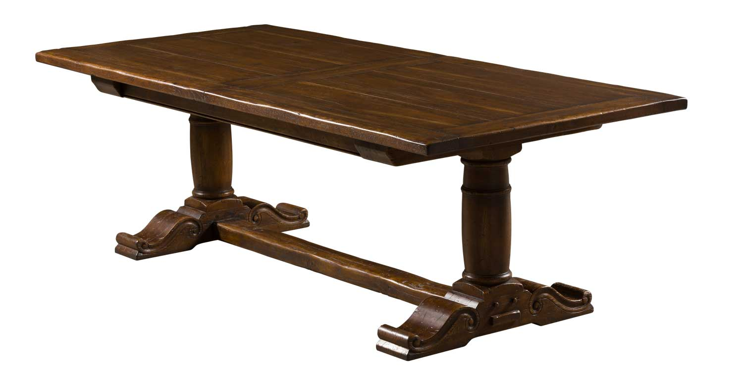

DIMENSIONS: 2.43m X 1.10m X .76m H
8’ X 43.3” X 29.9” H
2 Butterfly extensions- 40cm / 15.7” each (self storing)
More finishes available

