Touch of France
Dallas World Trade Center
2050 Stemmons Frwy Suite 10000
Unit 155 Dallas, Texas 75207-3211
Tel: 214-698-1600
Fax: 214-698-1601
www.touch-of-france.com

CHAMBORD
DINING TABLE

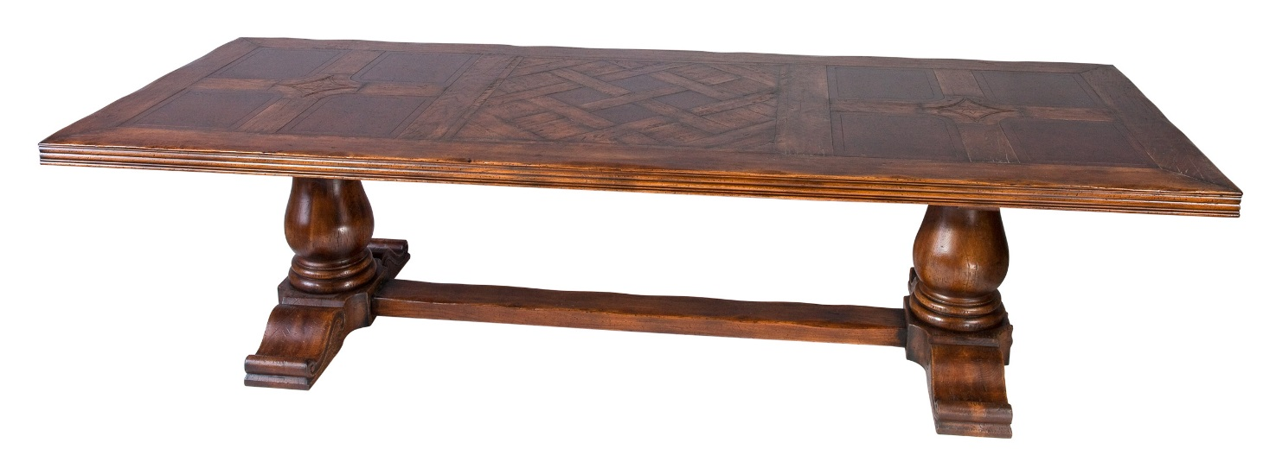

DIMENSIONS: AVAIL- 270cm, 300cm, 330cm, 360cm L
AVAIL- 9’, 10’, 11’, 12’ L
1.20m / 47.2” D
HEIGHT- 0.78m/30”
Oak and burl parquetry /custom in any dimension/ extensions can be added
Other finishes available

