Touch of France
Dallas World Trade Center
2050 Stemmons Frwy Suite 10000
Unit 155 Dallas, Texas 75207-3211
Tel: 214-698-1600
Fax: 214-698-1601
www.touch-of-france.com

CARRE
COFFEE TABLE
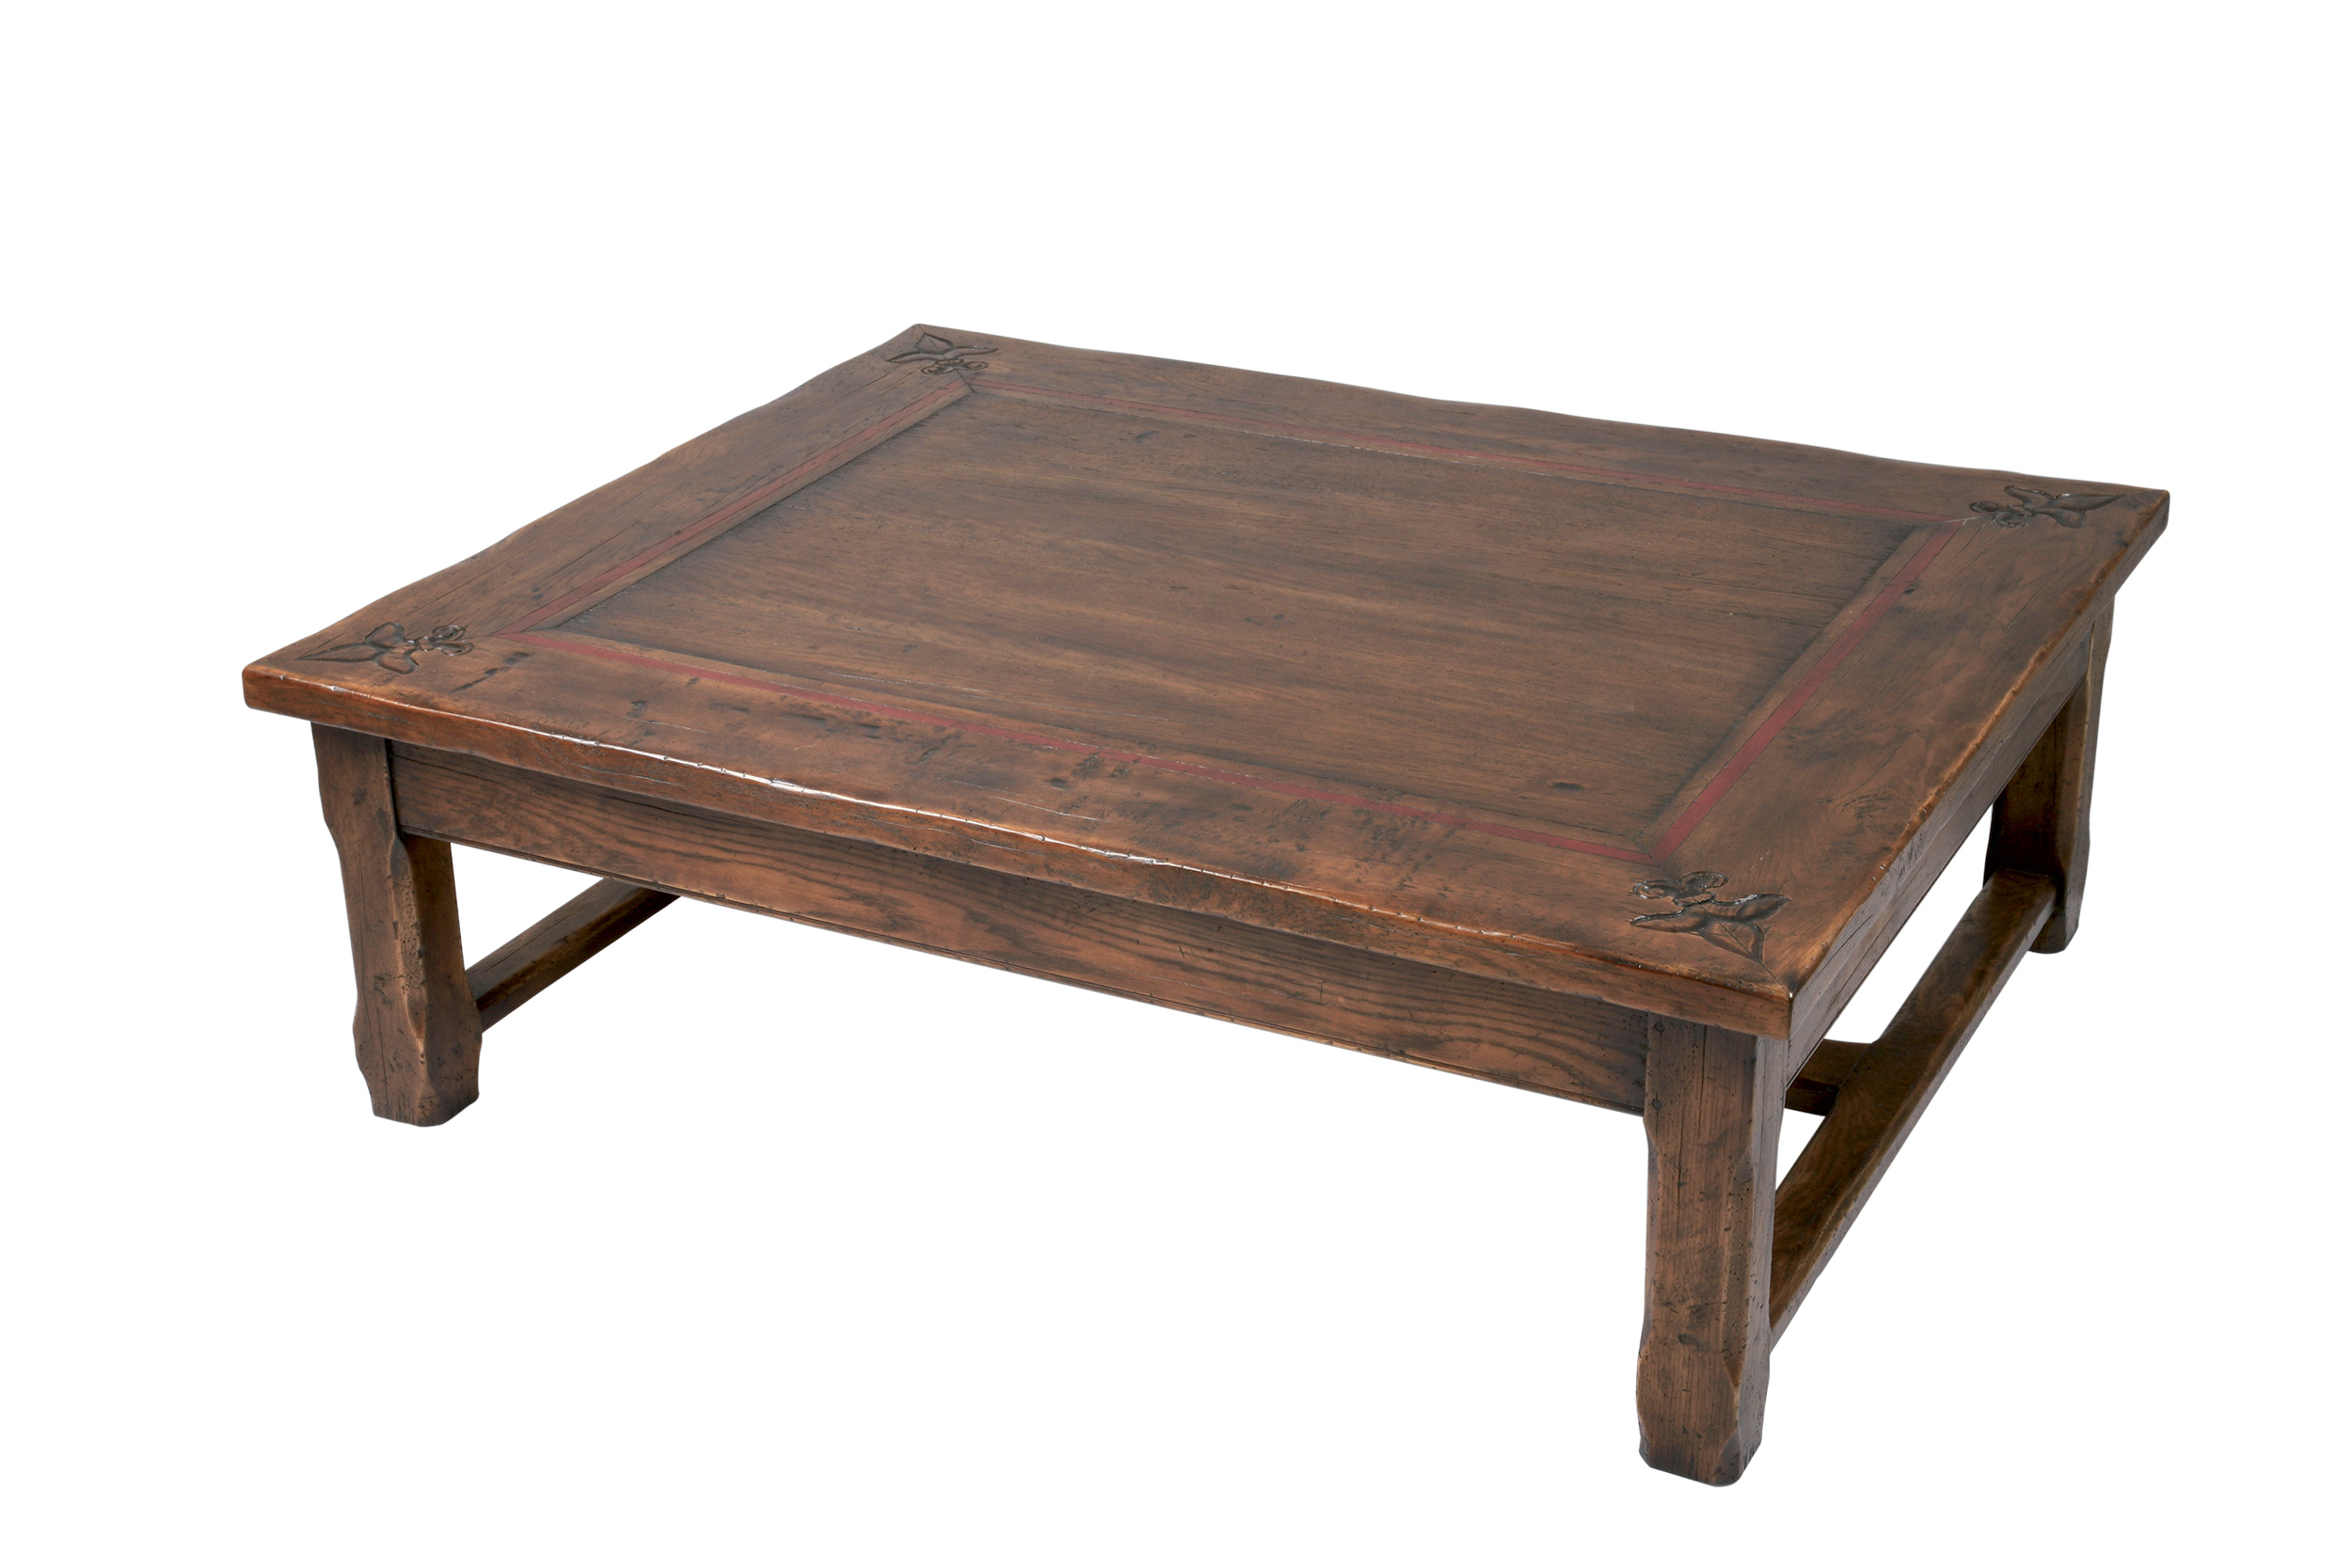

DIMENSIONS: SQUARE- 1.16m x 1.16m x .50m h
46” x 46” x 19.7” h
RECTANGLE- 1.50m x 1.20m x .50m h
60” x 48” x 19.7”h
2 drawers

