Touch of France
Dallas World Trade Center
2050 Stemmons Frwy Suite 10000
Unit 155 Dallas, Texas 75207-3211
Tel: 214-698-1600
Fax: 214-698-1601
www.touch-of-france.com

CAMPAGNE ROUND
DINING TABLE

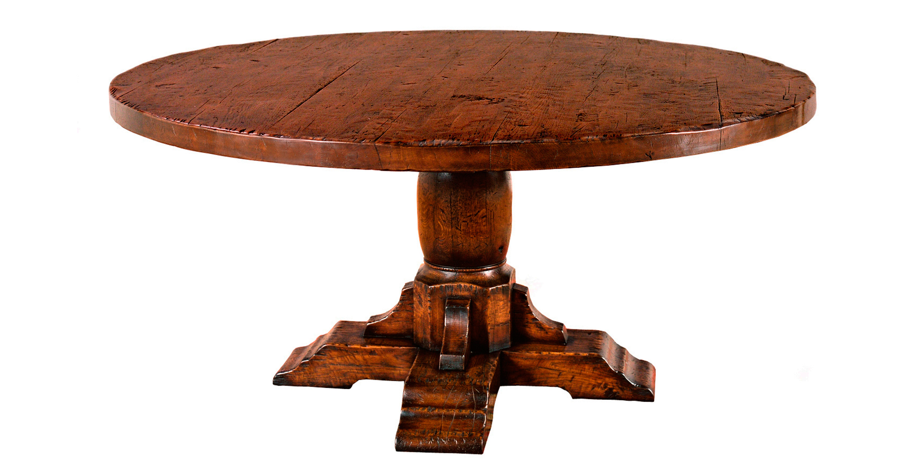

DIMENSIONS: AVAIL- 1.50m, 1.68m, 1.83m DIAM
AVAIL- 60”, 66”, 72” DIAM
HEIGHT- 0.78m/30”
Other finishes available

