Touch of France
Dallas World Trade Center
2050 Stemmons Frwy. #10000
Unit 155 Dallas, Texas 75207
Tel: 214-698-1600
www.touch-of-france.com

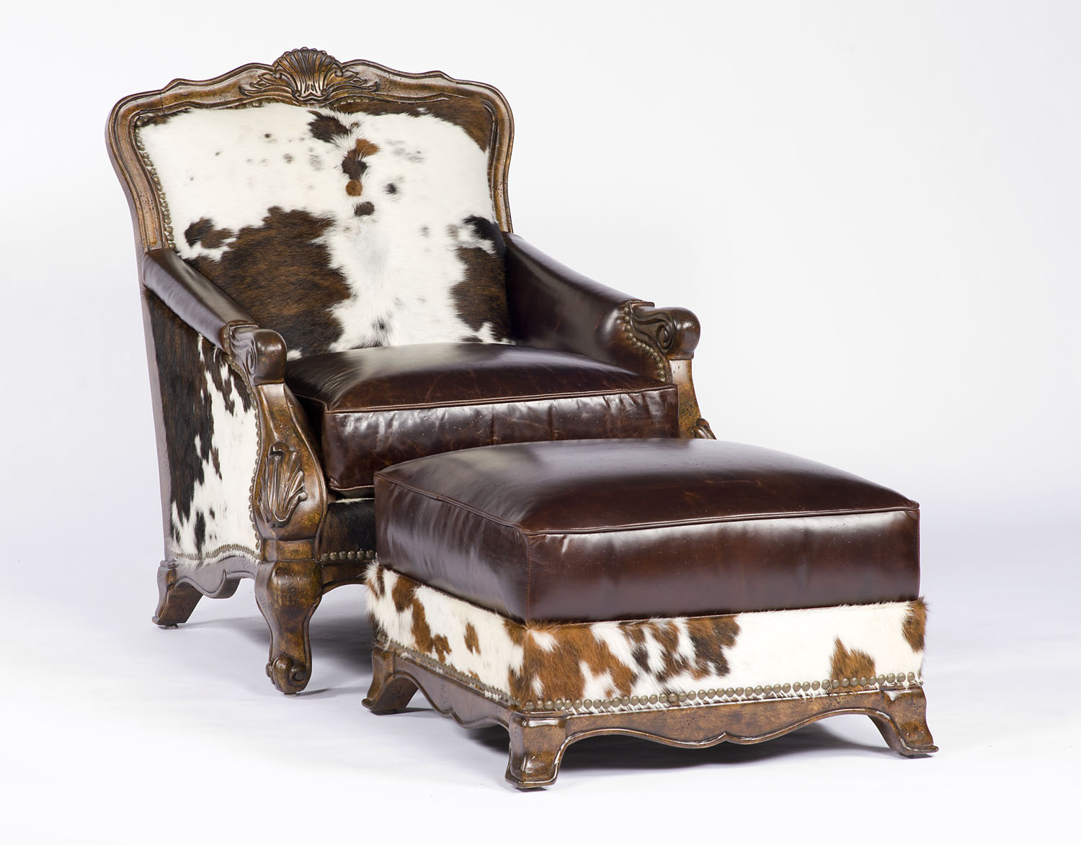

PR494-10-BUCKLEY-CHAIR

42H x 34W x 40D

PR494-11-BUCKLEY OTTOMAN

18H x 27W x 27D

