Touch of France
Dallas World Trade Center
2050 Stemmons Frwy. #10000
Unit 155 Dallas, Texas 75207
Tel: 214-698-1600
www.touch-of-france.com

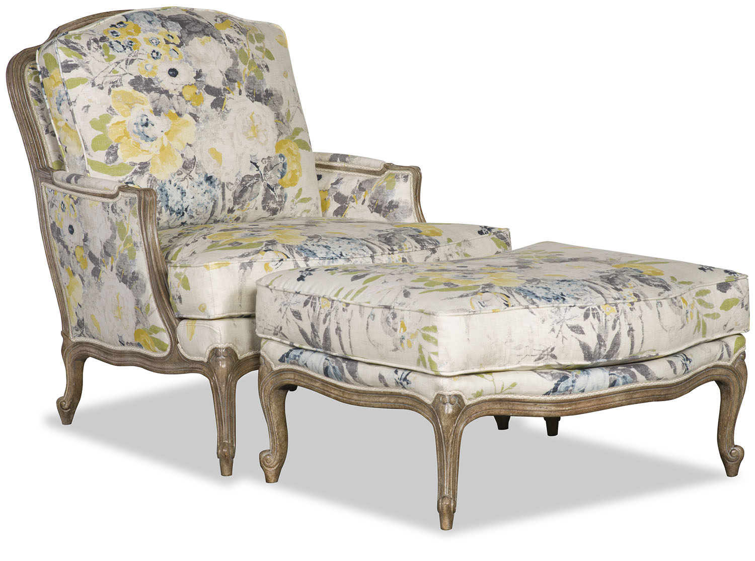

BAILEY FRENCH BERGERE

PR-6373-BAILEY
36H x 33W x 38D

BAILEY OTTOMAN
PR-6373-11-OTTOMAN
19H x 34W x 24D
Available in multiple fabric, leather and finish
Options
COM avail

