Touch of France
Dallas World Trade Center
2050 Stemmons Frwy Suite 10000
Unit 155 Dallas, Texas 75207-3211
Tel: 214-698-1600
Fax: 214-698-1601
www.touch-of-france.com

BOURG PHILIPPE COFFEE
TABLE WITH LIFT

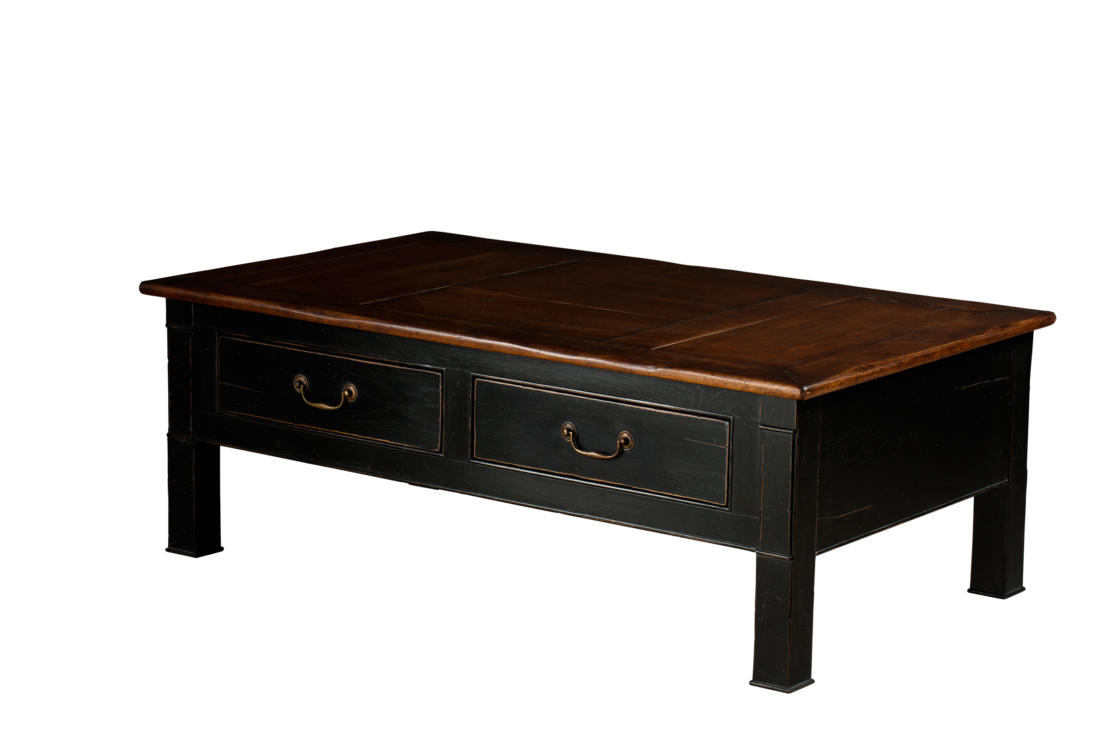

DIMENSIONS:1.35m X .80m X .45m h
53.1” X 31.5” X 17.7” h
2 Drawers

