Touch of France
Dallas World Trade Center
2050 Stemmons Frwy Suite 10000
Unit 155 Dallas, Texas 75207-3211
Tel: 214-698-1600
Fax: 214-698-1601
www.touch-of-france.com

BOHEME CONSOLE
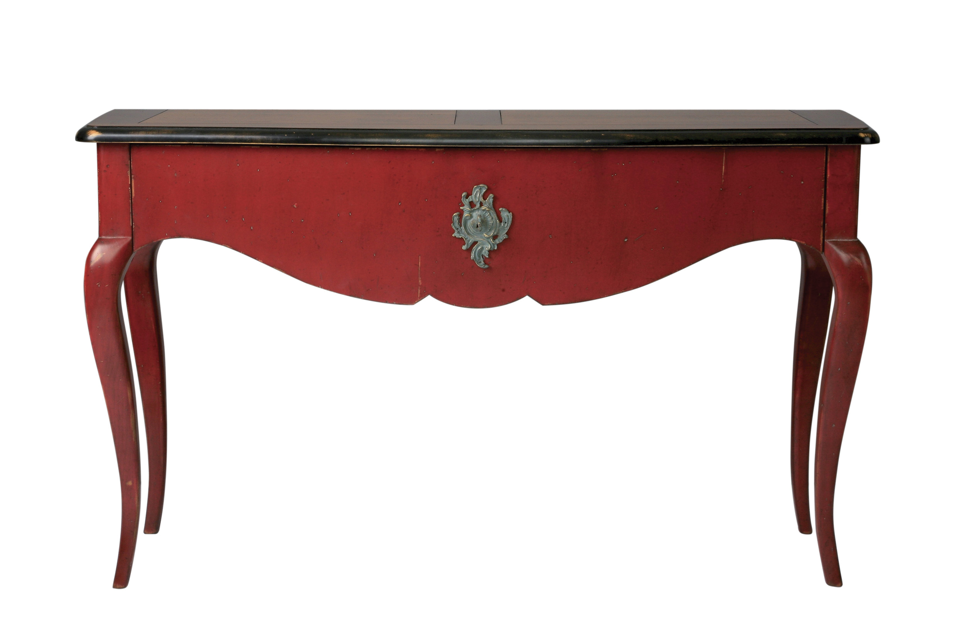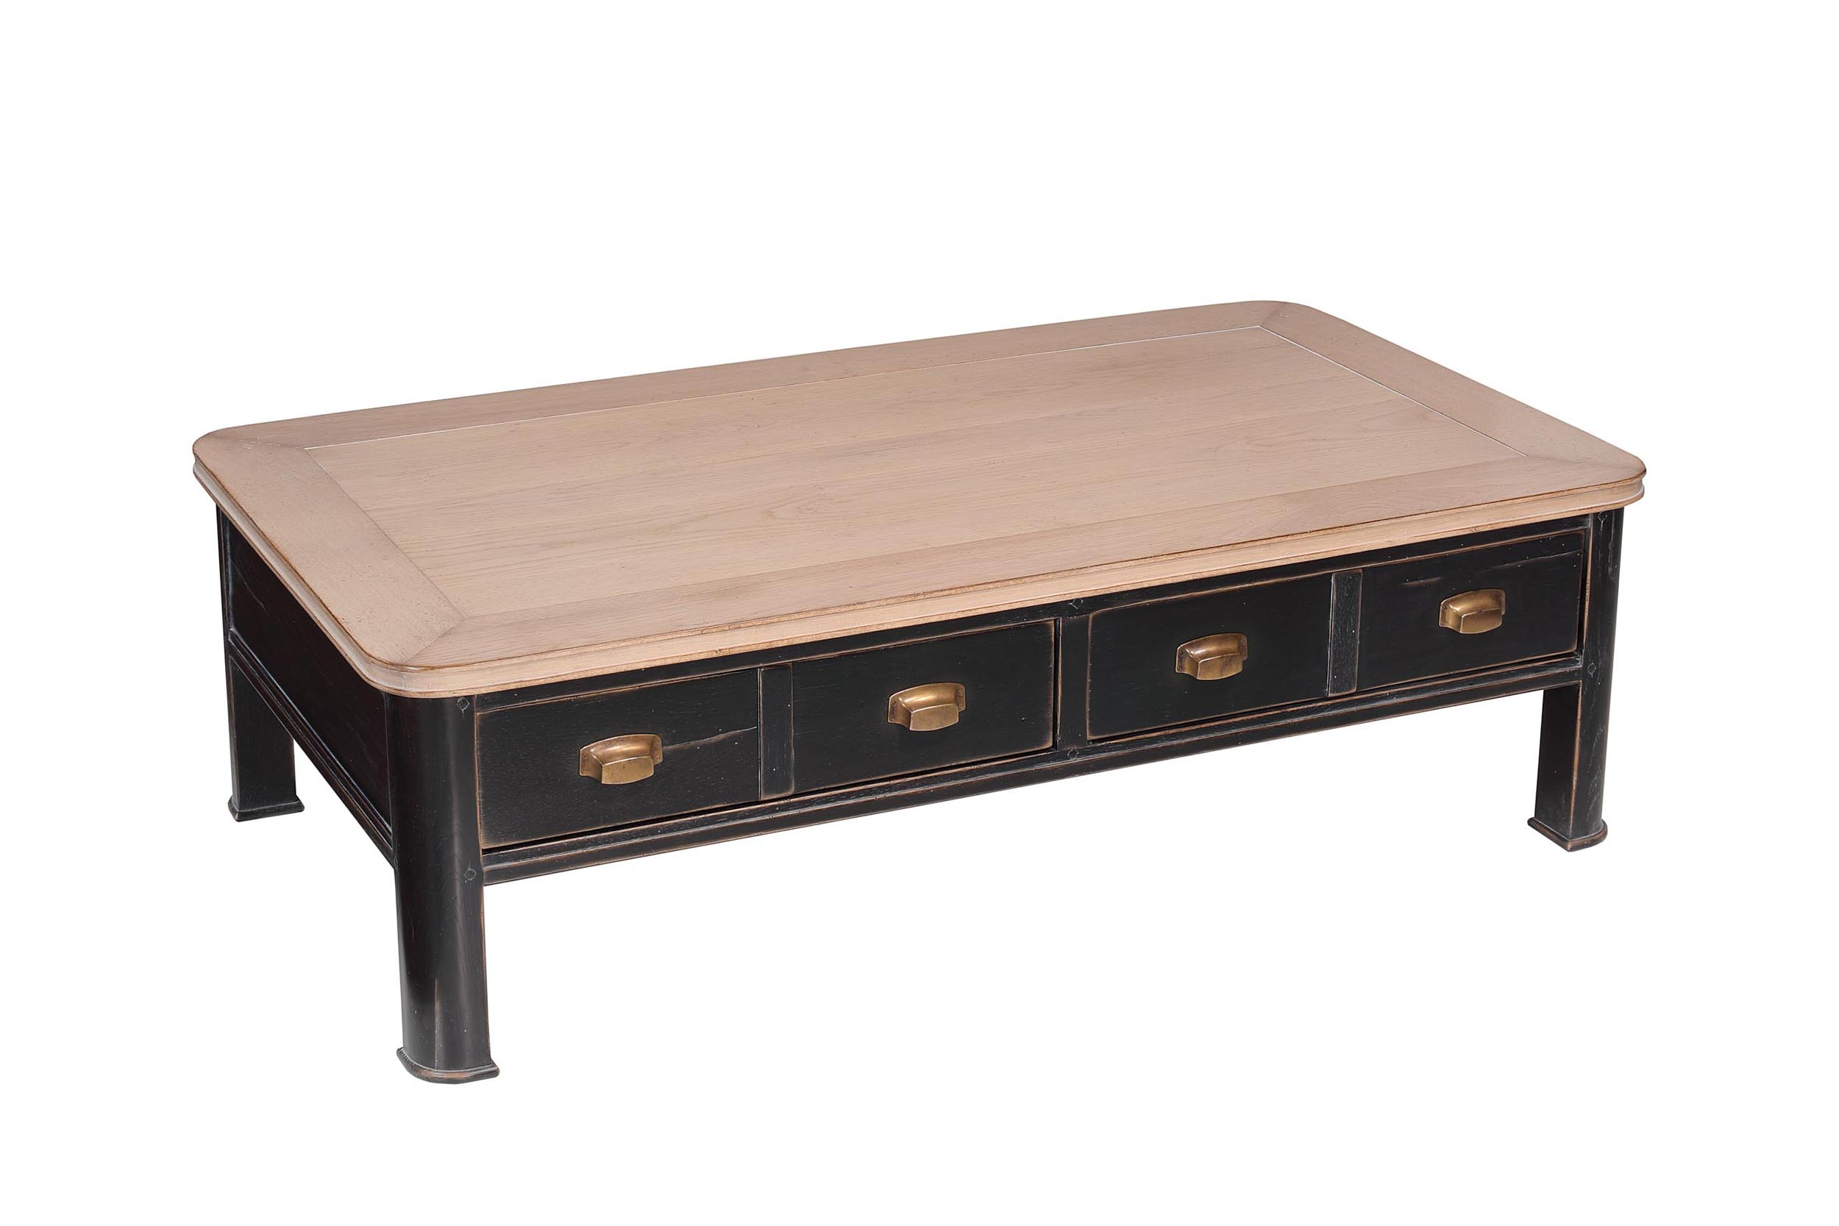
DIMENSIONS: 1.40m X .44m X .80m h
55.1” X 17.3” X 31.5” h
1 Drawer
Other finishes available

