Touch of France
Dallas World Trade Center
2050 Stemmons Frwy Suite 10000
Unit 155 Dallas, Texas 75207-3211
Tel: 214-698-1600
Fax: 214-698-1601
www.touch-of-france.com

BALZAC CONSOLE
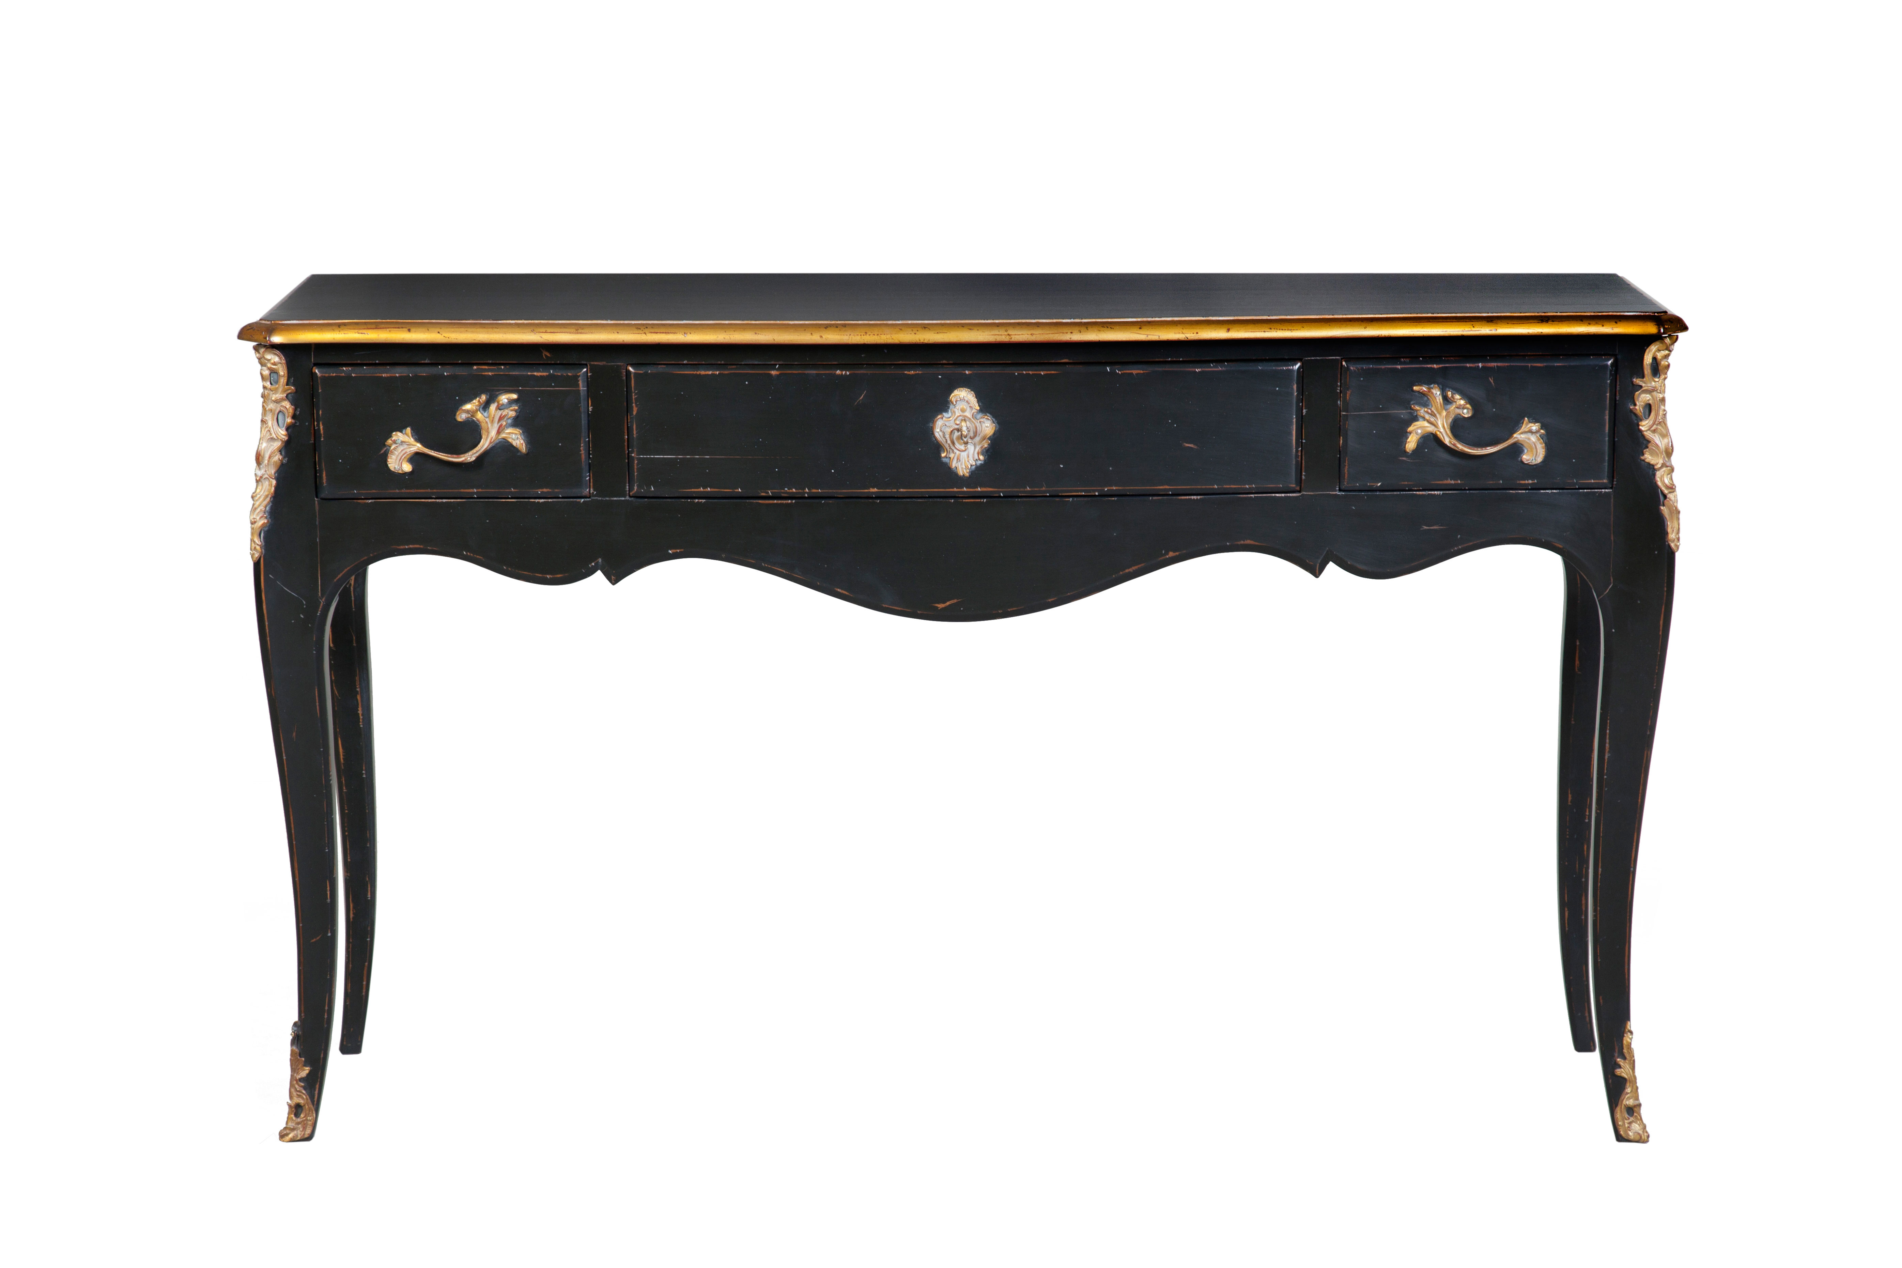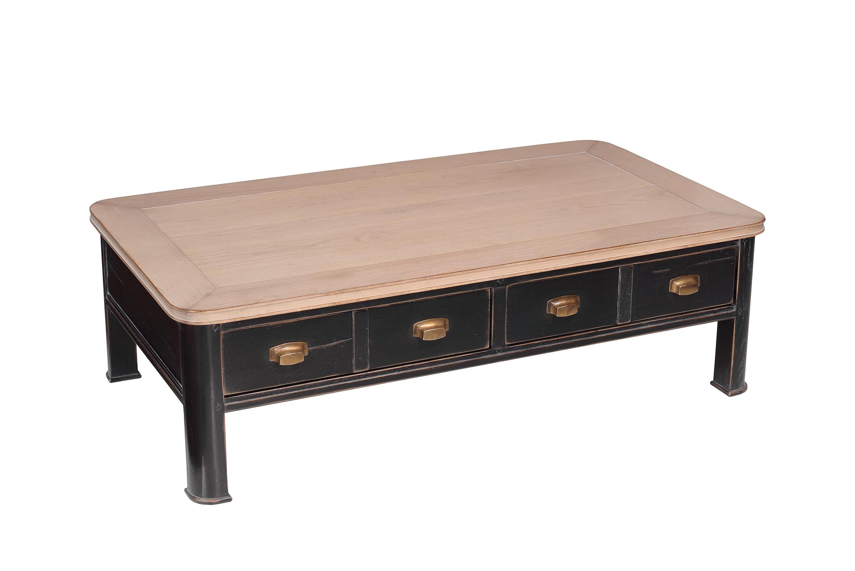
DIMENSIONS: 1.50m X .42m X .89m h
59” X 16.6” X 35.4” h
3 Drawers
Other finishes available

