Touch of France
Dallas World Trade Center
2050 Stemmons Frwy Suite 10000
Unit 155 Dallas, Texas 75207-3211
Tel: 214-698-1600
Fax: 214-698-1601
www.touch-of-france.com

AUBERGE
DINING TABLE
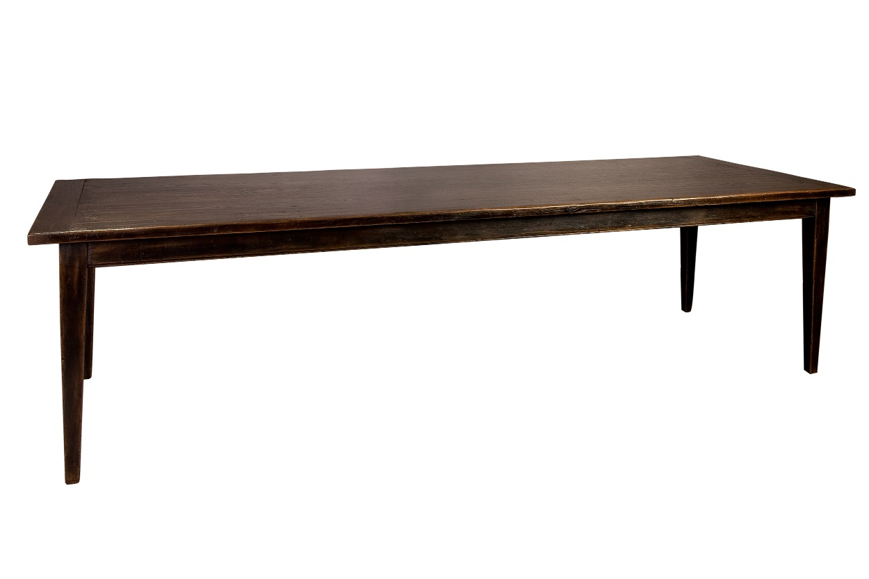

DIMENSIONS: 2.20m X 1.00m X .76m H
86.6” X 39.4” X 29.9” h
1 Butterfly extension for each end of the table
Each- 50cm/ 19.7” (each extension is self-stored)
Other finishes available

