Touch of France
Dallas World Trade Center
2050 Stemmons Frwy Suite 10000
Unit 155 Dallas, Texas 75207-3211
Tel: 214-698-1600
Fax: 214-698-1601
www.touch-of-france.com

MENLO PARK
DINING TABLE

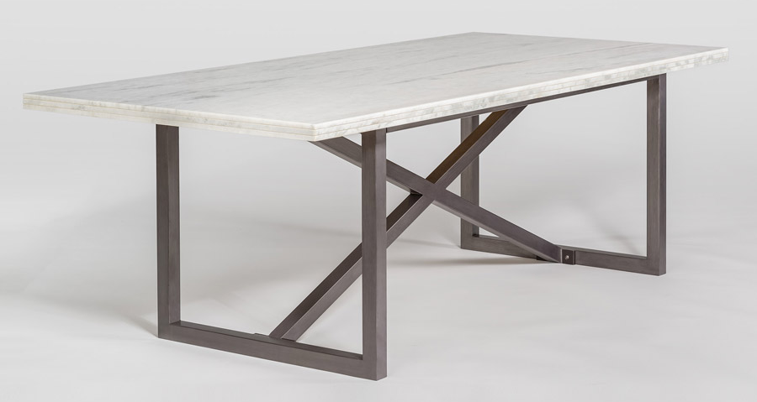
Marble: Cloud
Metal: Burnished Riviera
Material Type: MARBLE, METAL
Dimensions: 42 × 88 × 30 in

