Touch of France
Dallas World Trade Center
2050 Stemmons Frwy Suite 10000
Unit 155 Dallas, Texas 75207-3211
Tel: 214-698-1600
Fax: 214-698-1601
www.touch-of-france.com

ROWAN
SIDEBOARD

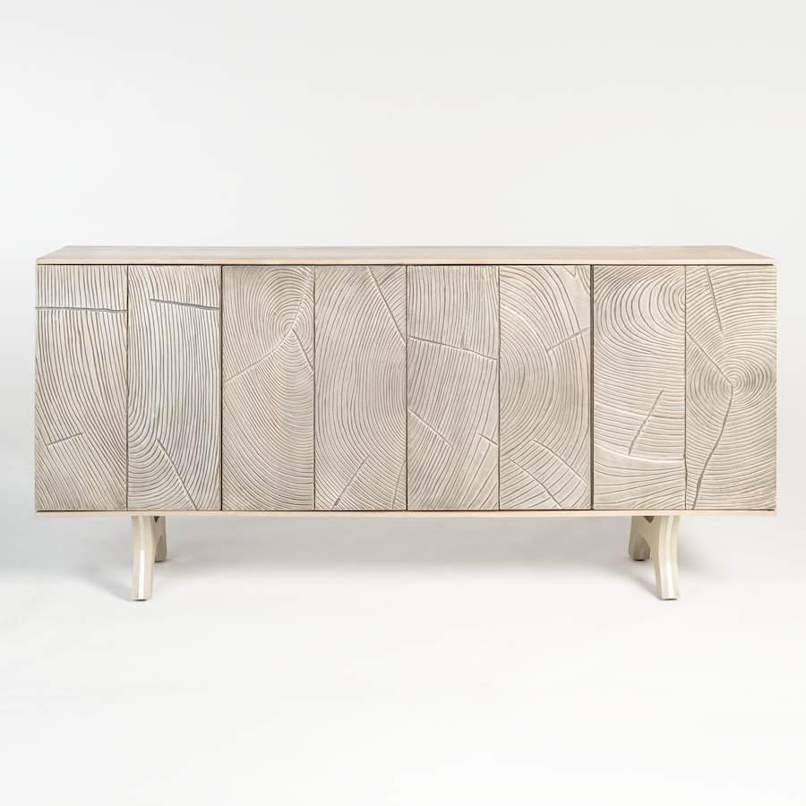
Wood: Provincial Dusk
Metal: Refined Pewter
Material Type: MANGO WOOD, METAL
Dimensions: 18 × 74 × 34 in

