Touch of France
Dallas World Trade Center
2050 Stemmons Frwy Suite 10000
Unit 155 Dallas, Texas 75207-3211
Tel: 214-698-1600
Fax: 214-698-1601
www.touch-of-france.com

NANTUCKET DINING CHAIR

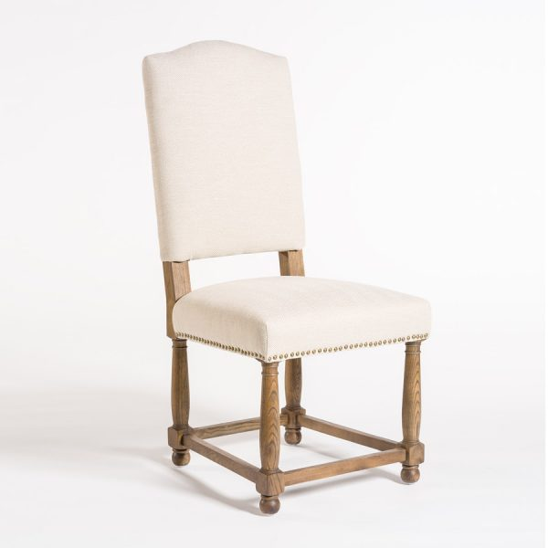
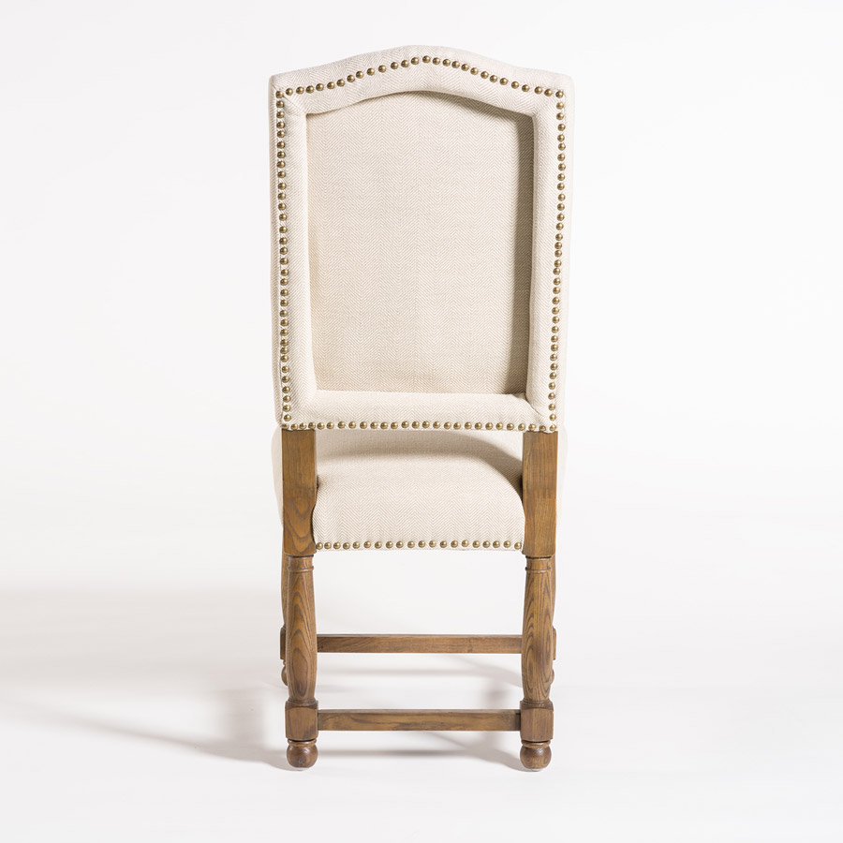

Fabric: Cement Herringbone
Wood: Weathered Oak
Material Type: BIRCH WOOD, UPHOLSTERY
Dimensions: 25 × 20 × 43.5 in

