Touch of France
Dallas World Trade Center
2050 Stemmons Frwy Suite 10000
Unit 155 Dallas, Texas 75207-3211
Tel: 214-698-1600
Fax: 214-698-1601
www.touch-of-france.com

CARTER 84” EXTENDABLE
DINING TABLE

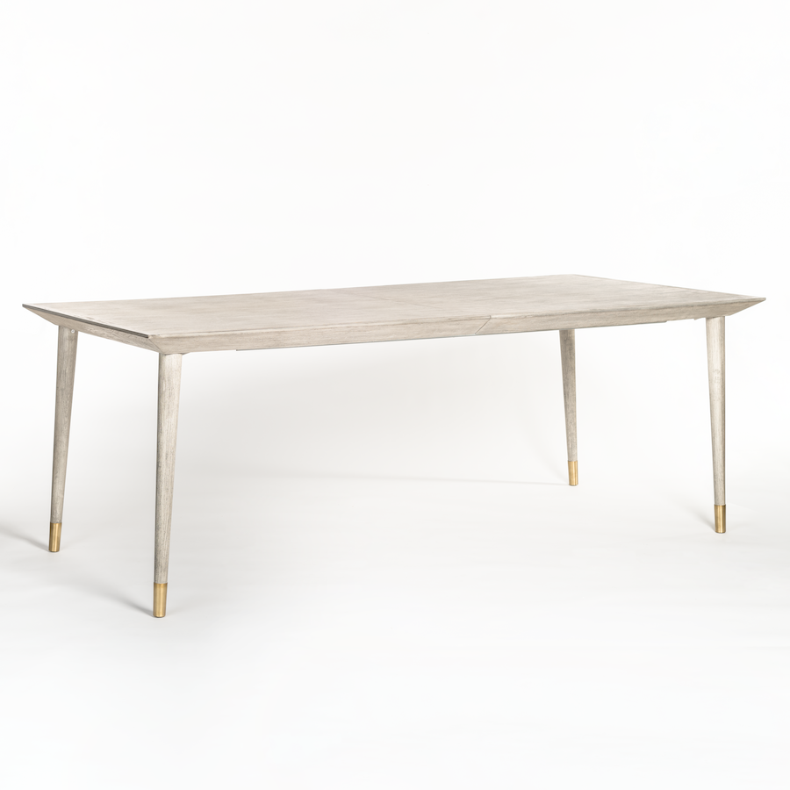

Wood: Brushed Smoke
Material Type: BEECHWOOD
Dimensions: 84 × 40 × 30 in
Extends from 84″ to 108″ with 24″ removable leaf

