Touch of France
Dallas World Trade Center
2050 Stemmons Frwy Suite 10000
Unit 155 Dallas, Texas 75207-3211
Tel: 214-698-1600
Fax: 214-698-1601
www.touch-of-france.com

ABBEY NESTING TABLES
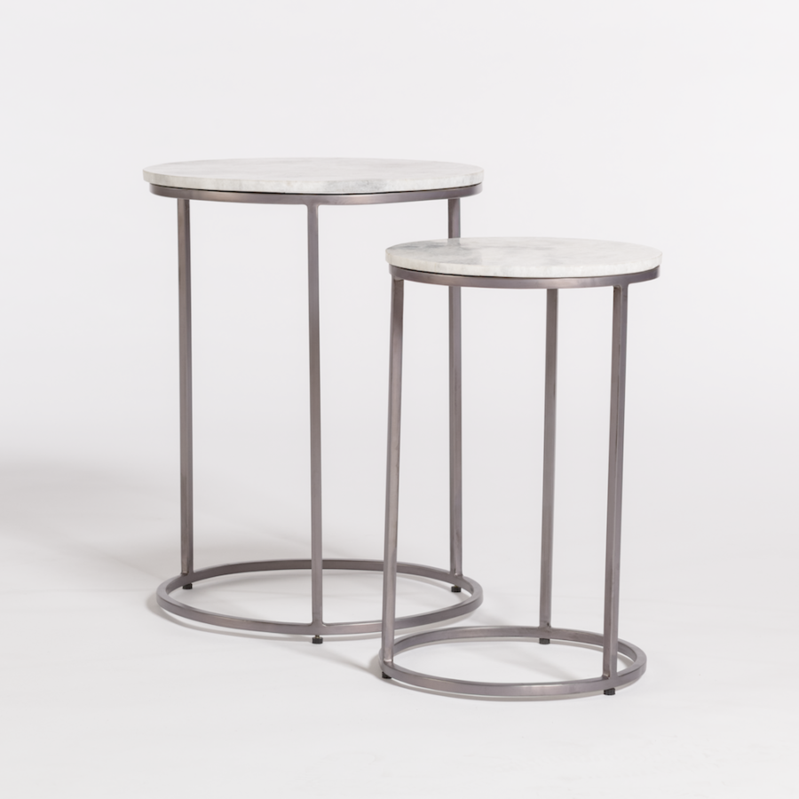

Metal: Burnished Riviera
Marble: Cloud
Material Type: MARBLE, METAL

Dimensions: 16.5 × 16.5 × 21.5 in

